Taxonomy Recognition Process

For

Acknowledged Status

Version 2013-04-09

Copyright © XBRL International Inc. 2003-2013

Editors
Name | Contact | Affiliation
Yossef Newman | ynewman@deloitte.com | Deloitte
Pierre Hamon | Hamon.pierre@etxetera.com | etXetera Solutions
Makoto Koizumi | koizumi@mercuryandearth.com | Mercury and Earth
Tony Fragnito | tonyf@xbrl.or | XBRL International
Angela Rose | angelar@xbrl.org | XBRL International
Abstract
This document describes the process and requirements for official Acknowledged level recognition of the taxonomy by XBRL International, Inc. (XII). The granting of Acknowledgement leads to the listing of the taxonomy on the XBRL web site with other recognized taxonomies and may result in a press release being issued jointly by XII and the taxonomy owner, at the request of the submitter and approval of XII. Acknowledged taxonomies are required to be in compliance with the XBRL Specification(s) and meet defined standards of documentation and hosting, among other requirements, which are detailed in this document.

In an effort to ensure that taxonomies listed as acknowledged by XII are up to date, the Acknowledged status of the taxonomy will remain valid for a period of 24 months. At the end of this period official recognition will automatically expire unless renewed. Recognition status will also expire automatically, when an Acknowledged Taxonomy undergoes any publicly available substantial revision or new release. Acknowledgement does not automatically carry over to a new version, and will automatically cause the acknowledged version to be labelled and listed as “Taxonomy Superseded”. The guidelines for recognition renewal are detailed in Section 7 of this document.

The Taxonomy Recognition Task Force (TRTF) is responsible to the XII Best Practices Board (BPB), exercising the powers delegated to it by the BPB to administer the taxonomy recognition process. These procedures and requirements apply to taxonomies recognised by XII, and not to jurisdictions of XII. Any form of taxonomy or project recognition by an official jurisdiction of XII does not imply recognition by this program or XII.
These procedures and requirements apply to taxonomies submitted for Acknowledgement after the date of publication of this document. Taxonomies that were granted Acknowledged status under previous version of this document retain the recognition status previously accorded, however all currently acknowledged taxonomies will be subject to the above described expiration provision.

Status
This document is a recommendation of the TRTF approved by the BPB. The document represents the official XII policy as of the date approved. Circulation of this document is unrestricted, however copyright rules apply. Recipients are invited to submit comments to the trtf@xbrl.org and/or the bpb@xbrl.org.

Table of Contents
Editors 1
Abstract 1
Status 2
Table of Contents 3
1. Goals 4
2. Taxonomy Recognition 4
3. Acknowledged Taxonomies 5
3.1. Criteria for granting Acknowledged status 5
3.2. Submitting the taxonomy 5

3.3. Reviewing the Taxonomy 6
4. Diagrammatic Overview of the Acknowledgement Process 7
5. Documentation 7
5.1. Summary Document and Taxonomy Information 7
5.2. Statements on Intellectual Property Status 8
6. Taxonomy Naming and Availability on the Web 9

6.1. Linking to an Acknowledged taxonomy not hosted by XBRL International 9
6.2. Ongoing verification of an externally hosted, Acknowledged taxonomy 9
7. Other Process Details 9
7.1. Fees for submission of taxonomies for recognition 9
7.2. Process for periodic updates to Acknowledged taxonomies 10
8. Taxonomy expiration and renewal 10
Appendix A: Documentation Details 12

Appendix B: Acknowledged Status Workflow 13

Appendix C: Taxonomy Acknowledgement Status Checklist 14

Appendix D: TRTF Reviewer Feedback Form 16

Goals
Goals for the acknowledgement program and the listing of recognised taxonomies on the XII web site include:
- Documentation Quality Assurance: Establish and promote a standard set of requirements for taxonomy documentation.
- Central Taxonomy Access Point: Encourage the dissemination and access to recognized taxonomies by maintaining a central portal on the XII web site.
- Transparency: Provide a documented recognition process which is easily understood.
- Technical Quality Assurance: Ensure that recognized taxonomies validate to the XBRL Specifications.

Taxonomy recognition does not imply review of taxonomy content, the reporting requirements are not the responsibility of XII and XII is not responsible for confirming that the taxonomy meets all reporting requirements for the specified domain.

Taxonomy Recognition
This document describes the process and requirements to attain Acknowledged status of a submitted XBRL taxonomy. The document is meant to guide both the submitter, the TRTF and XII Staff in support of a consistently applied program which provides market value.
Acknowledgement is available to any XBRL taxonomy that is available to the public with certain limitations. These limitations, which may preclude a taxonomy from being recognized, include such considerations as:
- the standing of the taxonomy author within the domain
- the nature of the information being captured (for example taxonomies which seek to capture illegal or inappropriate information or support illegal activities will not be considered)
taxonomies which substantially duplicate established market practice or trivial taxonomies In this document the term “XBRL Specification” shall mean the XBRL Specification and any modular extension to the XBRL Specification in effect at the time the taxonomy is submitted for recognition.
In cases were the taxonomy is constructed using draft recommendations of the XBRL Specification at the time of submission, it MAY be granted Acknowledged status with an exception for the technical validation not covering the sections that are constructed with the draft recommendation.
Any taxonomy that includes files in its DTS that are not owned by the submitter (e.g. extension taxonomies) are eligible to receive only that level of recognition granted to taxonomies constituting or containing the included files (or which is contemporaneously being sought for said files).

Acknowledged Taxonomies
An Acknowledged taxonomy MAY be either a draft, on which feedback is being actively sought, or an officially issued taxonomy, which the owners see as complete. The taxonomy summary published on the web site SHALL identify whether the taxonomy is a draft or an officially issued version. It SHALL also identify the version of the XBRL Specification(s) on which the taxonomy is based.
It is likely that the TRTF will decline to recognise any taxonomy that it believes does not contribute to the goals of the recognition process and of XII, this is at the sole discretion of the task force.

Criteria for granting Acknowledged status
When establishing the eligibility of the taxonomy for Acknowledged status, the reviewer MUST determine that the preparer has satisfied the following criteria:
Technical Validity:
The taxonomy MUST comply with the latest version of the XBRL Specification unless otherwise approved.
The taxonomy MUST be fully valid against the XBRL Specification which is determined by testing in at least two validators.
Documentation:
The taxonomy MUST have the minimum set of documentation which identifies key facts about the taxonomy and includes certain statements on copyright and other legal issues. The documentation MUST include:
- A Summary Document and Taxonomy Information
- Statements on Intellectual Property Status
The requirements for this documentation are described in detail in Section 5: Documentation. Templates and standard statements for inclusion in Documentation are provided in Appendix A - Documentation Details.

Submitting the taxonomy
The taxonomy submitted for Acknowledgement MUST be e-mailed directly to the TRTF at TRTF@xbrl.org,
The XII Staff or reviewer MUST confirm receipt of the submission within 72 hours.

Reviewing the Taxonomy
The reviewer (a member of XII Staff or individual appointed by XII) is responsible for ensuring that the taxonomy meets the required criteria for acknowledgement.
The reviewer will submit the taxonomy and all related files, including the Taxonomy Acknowledgement Checklist, to the TRTF for a 10 business day review and comment period.
TRTF members may submit suggestions or requirements to the staff reviewer with copy to the TRTF members. Suggestions are comments which will likely not affect that members’ opinion as to the submissions eligibility for recognition. Requirements are comments which will likely affect the members’ opinion as to the submissions eligibility for recognition. These comments will be processed by the reviewer and provided a status which may include “resolved by reviewer”, “remains unresolved by reviewer”, “referred to submitter and resolved” or “referred to submitter and remains unresolved”.
After the required review and comment period the reviewer will submit the Taxonomy and related files, the Taxonomy Acknowledgement Checklist and the status of all suggestions and requirements received by TRTF members, including status, to the TRTF members for a vote. Comments received after the open review MAY not be included in the documents for vote at the sole discretion of the reviewer.
Members of the TRTF will have 5 business days to vote electronically on the granting of acknowledged status. Once a majority of the voting members have voted in the affirmative Acknowledged status may be granted, regardless of the time period elapsed.
- The steps involved in the process of granting Acknowledged status are set out in Appendix B - Workflow.
- Appendix C - XBRL Taxonomy Acknowledgement Checklist
- Appendix D- TRTF Reviewer Feedback Form
If the TRTF declines an application for Acknowledged status, it MUST state reasons for doing so. The response to the taxonomy submitter, in the case of declining to grant recognition, will be prepared by the XII reviewer and provided to the TRTF for comment prior to being released. The taxonomy submitter MAY appeal the decision of the TRTF to the BPB within 45 days of the decision. The appeal must include the TRTF reasoning for declining acknowledgement and the submitters rationale for appealing the decision.
If the owners of the taxonomy do not receive a response indicating that the application has been accepted or declined from the TRTF within 45 days of meeting all the requirements for Acknowledged status, including responding to any requirements and suggestions by TRTF members, they MAY appeal to the BPB for a decision. The TRTF expects to process all applications for Acknowledged status in 45 days or less, however the nature of the Taxonomy submitted, the results of the validation process and comments received by TRTF members cannot be known in advance. The XII reviewer MUST communicate with the Taxonomy submitter at a minimum of every 30 days to provide a status of the application process.

Diagrammatic Overview of the Acknowledgement Process
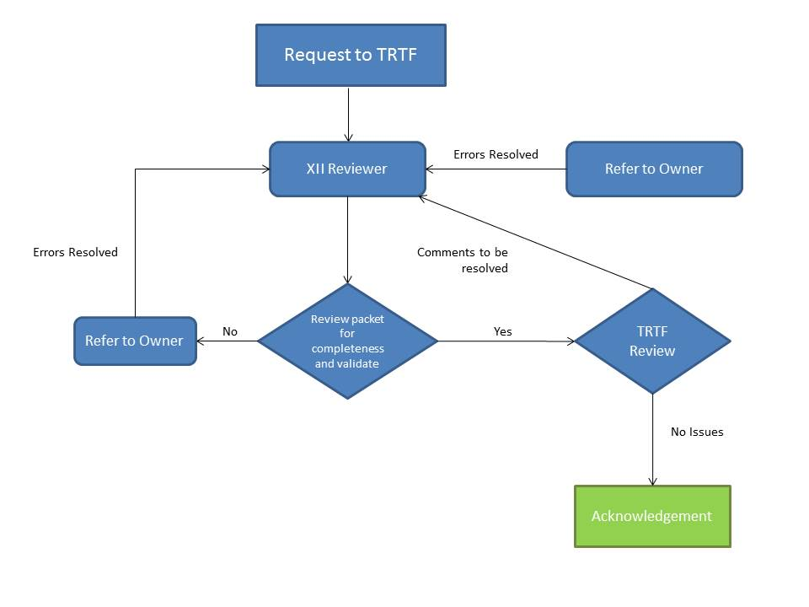

Documentation
Taxonomies submitted for recognition MUST have accompanying documentation which meets the minimum standards set out in this section.
Documentation MUST include a summary document in UK English, the standard language of XII. The summary, and any other documentation, MAY be provided in other languages determined by the taxonomy owners. XII will only validate the UK English version of provided documentation.
The information requirements in this section are the minimum requirements for recognition. Taxonomy users will benefit from additional explanatory documentation, including printouts of elements, sample instance documents and taxonomy guides. The nature and extent of user documentation will vary based upon the domain, complexity of the taxonomy and reporting requirements. Taxonomy authors are encouraged to consider the users of the taxonomy when documentation is being considered beyond these minimum requirements.

Summary Document and Taxonomy Information
A summary document for the taxonomy MUST at least state:
- Official name and version (if appropriate) of the taxonomy.
- Purpose and scope of the taxonomy.
- Owner(s) of the taxonomy.
- Date of issue.
- Status of the taxonomy (valid values are draft or official).
- The version of the Specification(s) on which the taxonomy is based (1).
- Contact details for information on the taxonomy.
- Namespace(s)
- Suggested Namespace Prefix(es).
- Active and tested URLs of the location of the taxonomy files.
- Description of references to other taxonomies, if any.

A sample template showing a layout of this summary information is included in Appendix A - Documentation Details. In order to avoid invalid URLs supplemental documentation SHOULD NOT include separate URLs for the taxonomy files; instead they should reference or link to the URL listed in the summary document.
When the taxonomy is constructed with XBRL draft recommendations, full documentation should be provided including: the way the draft recommendation was implemented, the business case supporting the implementation and whether a comparative analysis was performed with other taxonomies that have implemented the same draft recommendation.

Statements on Intellectual Property Status
The summary document MUST contain statements which govern use of the taxonomy.
- Royalty-free use: A statement that the taxonomy is provided for use without licence fees or similar restrictions, in accordance with the Intellectual Property policy of XII.
- Copyright: A statement that XII accepts no responsibility or liability for claims of infringement on the copyrights of others.
- Liability: A statement that the taxonomy is provided without warranty and that neither the owners nor XII accepts liability, or may be exposed to damages arising from use of the taxonomy.
Each individual file comprising the taxonomy must contain at a minimum an indication of the copyright owner, and either: (1) a URL where the ownership and permitted use of the taxonomy is stated, or (2) the full text of such statement. This requirement applies to all files owned by the submitter. This recognises that the submitter might be submitting the taxonomy that is an extension of one or more taxonomies that already have (or are contemporaneously applying for) recognition under this program.

Taxonomy Naming and Availability on the Web
The authoritative version of taxonomies recognised by XII MUST be publicly accessible by a URL. The owners MAY choose to have the taxonomy hosted either by XBRL International or an alternative site. A listing of recognised taxonomies will be on the XBRL International site including links to summary documents, which will in turn provide the URLs of taxonomy files.
All taxonomies hosted by XBRL International MUST follow the XBRL International namespace and file-naming convention. Acknowledged taxonomies hosted elsewhere SHOULD follow these requirements.
In linking to the taxonomy hosted on an alternative site, XBRL International will use the following path naming convention:
{taxonomyURI}/{taxonomyDocumentFileName)
Additional rules apply to the taxonomy which is hosted on a site other than the XBRL International website:

Linking to an Acknowledged taxonomy not hosted by XBRL International
If a taxonomy submitter chooses to have the taxonomy hosted elsewhere, they MUST permit a link on XII website to point to the location of the taxonomy. The submitter MUST provide trtf@xbrl.org notice of any changes to the link within 5 days. If the taxonomy is no longer available at the provided link and the required notice has not been provided, the recognised status of the taxonomy SHALL be suspended until either a correct new address has been supplied to trtf@xbrl.org or the taxonomy is again available through the original link.

Ongoing verification of an externally hosted, Acknowledged taxonomy
XII will keep a copy of all Acknowledged taxonomies.. A copy will be made available to the public upon demand, as far as is practical. If the version that the taxonomy owners host externally differs from the copy kept by XBRL International, the recognised status of the taxonomy SHALL be suspended. Upon XII becoming aware of any difference, it SHALL inform the taxonomy owners as soon as practical and suspend the listing of the taxonomy on the XII website. Once the taxonomy owners have satisfied the TRTF that the situation has been rectified the recognition status SHALL be reinstated and the XII website updated accordingly.

Other Process Details

Fees for submission of taxonomies for recognition
The Taxonomy Recognition process is not limited to members of XBRL International or jurisdictions thereof. Taxonomies owned by non-members MAY be submitted for Acknowledged status by their owners. XII reserves the right to charge either members or non-members for the Taxonomy recognition and renewal process. At this time no fee is required for the service.

Process for periodic updates to Acknowledged taxonomies
Taxonomy owners may wish to issue periodic updates to the taxonomy granted acknowledged status. The nature of taxonomy updates will vary and may range from minor corrections of content to more substantive changes to content or structure.
Where a submission represents an update to an existing acknowledged taxonomy, the recognition process will consider the volume and nature of updates that have been made. Where changes are minor, isolated or part of a structured maintenance plan, reviews may be focused on the changes made. The extent of such review or a request to resubmit will be based upon the discretion of the TRTF upon a description of the changes made and a request to update the Taxonomy which has received acknowledged status. Any such reassignment, if other than a full review, will be for the remaining months of the taxonomy being updated. In case of taxonomies whose recognition status has expired, or is resubmitted due to significant revisions before the 24 month duration, a new application should be made.
As best practices for the periodic maintenance and update of taxonomies continue to develop, this process document may be updated to formally address the changes to the process or requirements for recognition.

Taxonomy expiration and renewal
In an effort to ensure that the taxonomies listed as acknowledged on the XII website are, in fact, current and up to date acknowledgement status will be granted for a period of 24 months. . At the end of this period official recognition will automatically expire unless renewed. Recognition status will also expire automatically, when an Acknowledged Taxonomy undergoes any publicly available substantial revision or new release. Acknowledgement does not automatically carry over to a new version, and will automatically cause the acknowledged version to be labelled and listed as “Taxonomy Superseded”.

Approximately 60 days prior to the expiration of acknowledged status a notice will be sent from XII to the taxonomy author of record notifying them that the acknowledged status of the taxonomy will expire. The author has the option to:

- Permit the taxonomy recognition to expire
- Request an extension with rationale
(i.e. For draft taxonomies, that comments are still being sought on that particular version – there is no newer version, and the process has just been slow.
(i.e. that the taxonomy is still relevant and the taxonomy developers encourage its use.)
- Request a staff review if there have been no changes to the taxonomy, which if verified, would allow the taxonomy to be acknowledged for another 24 months.
- Submit an updated taxonomy package with changes to apply for acknowledgement.

The TRTF MAY, at its discretion, suspend the Acknowledged status of taxonomies based on old, superseded criteria including a taxonomy using noncurrent versions of the XBRL Specification(s). XII will provide a minimum of 60 days notice to the taxonomy author of such proposed action. After such notice period references to such taxonomy’s will be on the XII web site will remain with a status of expired.

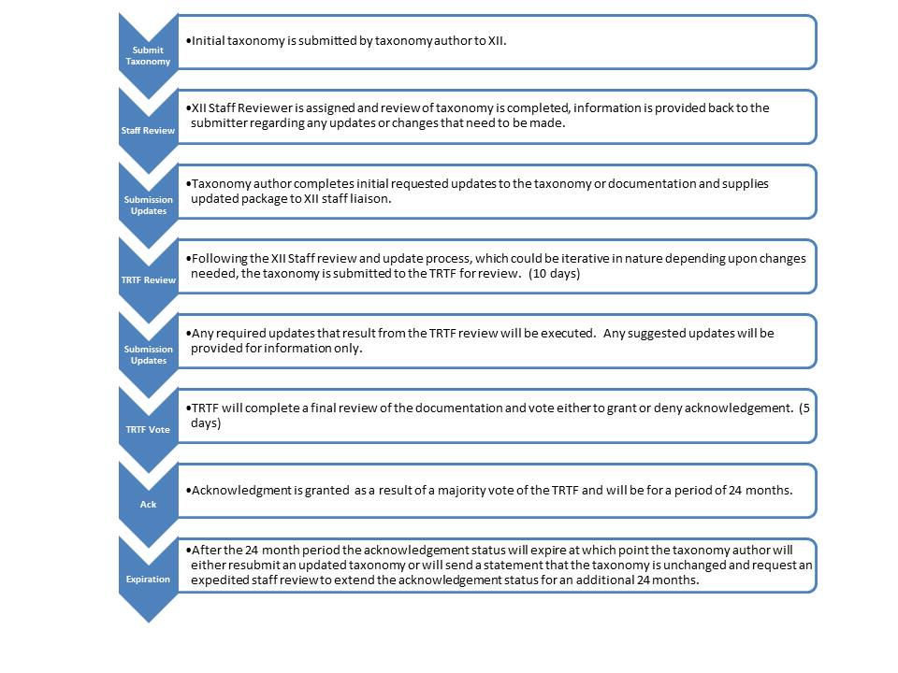

Appendix A: Documentation Details
A sample template showing the layout of taxonomy summary information is shown below. The format is purely for illustration. Other examples from recognised taxonomies can be seen on the XBRL International website or on websites to which it links. Additional information, for example printouts of elements, is also desirable, as explained in Section 5: Documentation.
Name of Taxonomy

Purpose and Scope | Brief description of taxonomy: e.g. "Represents UK Generally Accepted Accounting Principles (GAAP) as of 31 December 2012."
Owner(s) | e.g. XBRL UK Limited
Date | ccyy-mm-dd (ISO 8601 format) e.g. 2013-06-30
Status | Public Working Draft or Final
Recognition Level | XBRL International “Acknowledged”
Specification version(s) | e.g. XBRL Specification Version 2.1, dated 2003-12-31 with errata corrections to 2005-04-25, Dimensions, Formula.(Please indicate versions)
Contact | E-mail contact is mandatory; phone optional
Comments | Example of additional optional information: e.g. "This is a draft for initial implementation trials."
Namespace | e.g. http://www.xbrl.org/etc.
Physical location of taxonomy files | e.g. http://www.xbrl.org/.......xsd (Schema)  http://www.xbrl.org/.............-labels.xml (Label linkbase)  Etc. for other files
Summary document | e.g. http://www.xbrl.org/.....doc  URL of this document. The XBRL International website entry for the taxonomy will point to this URL.
References to other taxonomies | e.g. "None." or names and URLs of taxonomies concerned.
Legal statements | Statements indicating royalty free use, warranties, disclaimer of liability etc.

The www.xbrl.org hyperlinks assume the taxonomy is hosted on the XBRL International website. Red represents alternative text. Green text is just for example.

Appendix B: Acknowledged Status Workflow
The following are the main steps involved in the granting of Acknowledged status to the taxonomy. Information on the process is published on the XBRL International website at http://www.xbrl.org/TaxonomyRecognition/. Questions on the process may be directed to TRTF@xbrl.org.
- Taxonomy owners MUST ensure the taxonomy meets the criteria for Acknowledged status set out in this document BEFORE submitting it to XBRL International. This means:
- Ensuring namespaces and filenames are correctly set for the intended hosting environment.
- Testing for XBRL specification validity in the required number of validators. The test reports confirming validity should be saved for submission to XII.
- Ensuring documentation meets the requirements outlined herein. Taxonomy owners seeking Acknowledged status MUST send a zip file containing all the taxonomy files and test reports confirming validity to TRTF@xbrl.org. If owners are submitting further information such as printouts of elements and instance documents for publication on the XBRL International website, the zip files MUST be separated as follows:
- Zip containing taxonomy files, summary document and explanatory taxonomy documentation only.
- Zip containing any printouts of taxonomy elements (in HTML or PDF etc).
- Zip containing instance documents.
This separation of zip files is to enable efficient management and review.
- If the taxonomy owners do not receive a message confirming receipt of the file within 72 hours, the owners SHOULD follow up with an e-mail to trtf@xbrl.org .
- XII reviewer MUST review the taxonomy in accordance with the criteria set out in this document. The reviewer is responsible to communicate with the submitter and the TRTF, as required, throughout the process.
- Taxonomy submitters MAY appeal to the BPB (via the e-mail address BPB@xbrl.org) against a refusal to grant Acknowledged status or over any failure to respond to an application for Acknowledged within 45 days, as described in Section above.

Appendix C: Taxonomy Acknowledgement Status Checklist

The preparer MUST ensure the documentation provided is sufficient for the reviewer to answer YES to all points listed below.

Taxonomy Name:
Taxonomy Owner:
Submitting Organisation:
Primary contact details:
Date submitted:

Technical validity:

XBRL testing – tool 1:
XBRL testing – tool 2:
Test reports submitted (if any)
Reviewer notes (if any)

Documentation contains:

Official name of the taxonomy
Purpose and scope of the taxonomy
Owners of the taxonomy
Date of issue
Status of the taxonomy (valid values are draft or final)
The version of the specification on which the taxonomy is based
The recognition level sought from XBRL International | Acknowledged Status
Contact details for further information on the taxonomy
Namespace(s)

….the taxonomy hosted by XBRL International MUST follow the XBRL International namespace and file naming convention. The convention is set out below. The taxonomy hosted elsewhere SHOULD follow these rules.
There must be an authority component. The authority MUST be server-based. URI syntax describes a server-based authority as:
<userinfo>@<host>:<port>
The host MUST be a domain name controlled by the authority issuing the taxonomy; the userinfo and port parts are optional.
The path must be present and must follow this pattern:
/jurisdiction/reportingType/accountingType/industry/{qualifier/}*versionDate
Suggested Namespace Prefix(es)
URLs of the location of the taxonomy files.
Description of references to other taxonomies, if any.

Intellectual Property Status Statements:

Royalty-free use: A statement that the taxonomy is provided for use without licence fees or similar restrictions, in accordance with the Intellectual Property policy of XBRL International.
Copyright: A statement that XBRL International accepts no responsibility for ensuring that the taxonomy does not infringe on the copyrights of others and that it does not accept any liability for any infringement.
Liability: A statement that the taxonomy is provided without warranty and that neither the owners nor XBRL International accept any liability for any damages to any third party which arise in any way from its use.
Each individual file comprising the taxonomy must contain at a minimum an indication of the copyright owner, and either: (1) a URL where a the ownership and use of the taxonomy is stated, or (2) the full text of such statement. This applies to all files owned by the submitter. This recognises that the submitter might be submitting the taxonomy that is an extension of one or more taxonomies that already have (or are contemporaneously applying for) the same level of recognition.

Appendix D: TRTF Reviewer Feedback Form
Name of Taxonomy:
Name of Reviewer:
Date:
Requirements - Items that will likely affect reviewer’s opinion as to the eligibility for recognition
Suggestions – Items that will be communicated to the owner, but may be addressed at the owner’s discretion

