**NOTICE TO SERVICE PROVIDERS**

**REQUEST FOR INFORMATION (RFI)** **FOR SOFTWARE VENDORS**

**CIPC RFI NO: 001/2016/2017**

1. **Introduction and purpose of the RFI**

Respondents are hereby invited for the supply of information for **Software Solution**. This RFI is neither a tender, RFP nor RFQ. No award shall be made in terms of this RFI. No conclusions will be drawn between respondents. There is no commitment from CIPC to procure system from any of the suppliers. The purpose of this request is to gather information and acquire a clear understanding of what the market has to offer regarding technical **specifications for the implementation of XBRL Programme**. The description of the process is summarized in the Terms of Reference that will be made available to respondents during the briefing Session. The same information can be requested via email see contact details below

1. **RFI procedure**

* Service providers to note that the RFI is published in the **Government Bulletin** and the **National Treasury Portal** and **Newspapers**
* The RFI Terms of Reference will be made available on ***CIPC Website under Tenders, rfi 001/2016/2017 :*** [www.cipc.co.za](http://www.cipc.co.za/) or can be requested via email addresses below
  1. **RFI RESPONSE FORMAT**
  2. **scm queries / REQUESTING OF TOR TO BE ADDRESSED TO**

**Ms Ntombi Maqhula OR Mr Solomon Motshweni**

Email address: [nmaqhula@cipc.co.za](mailto:nmaqhula@cipc.co.za) / smotshweni@cipc.co.za

* 1. **TECHNICAL QUERIES TO BE ADDRESSED TO**

**Mr Joey Mathekga:** Business Queries Email: [jmathekga@cipc.co.za](mailto:jmathekga@cipc.co.za)

**Mr Sello Ndlovu:** Technical and System issues: Email: [sndhlovu@cipc.co.za](mailto:sndhlovu@cipc.co.za)

1. **Timeframe**

**Below is the timeframe for the RFI**

|  |  |
| --- | --- |
| **OPENING DATE:** | **16/09/2016** |
| **CLOSING DATE:** | **17/10/2016** |
| **LAST DATE FOR QUESTIONS:** | **10/10/2016** |

**DETAIL OF THE BRIEFING SESSION**

|  |  |  |
| --- | --- | --- |
| **BRIEFING SESSION:**  **(*NOT* A COMPULSORY BRIEFING SESSION)** | **DATE:** |  |
| **TIME:** |  |
| **VENUE:** |  |

**RFI 001/2016/2017**

***CIPC Overview***

***A brief overview about CIPC in terms of:***

* ***History***

The **Companies and Intellectual Property Commission (CIPC)** was established in May 2011. Although a new entity, CIPC incorporated the former Companies and Intellectual Property Registration Office (CIPRO) and a unit in the **dti**’s Corporate and Consumer Regulation (CCRD) division, namely the Office of Companies and Intellectual Property Enforcement (OCIPE).

In today’s globalized, hypercompetitive economy, a nation’s wealth is significantly influenced by its business activity, the economic inclusion of its citizens as well as its’ level of innovation, as measured by the Intellectual Property that is developed and registered by its citizens. CIPC therefore has another important element to its mandate. It administers, regulates and protects South Africa’s Intellectual Property assets in accordance with the provisions of a range of legislation enacted over a number of decades. Creating an enabling environment for Intellectual Property has been the subject of much research and legislative reform and this process will continue to gain momentum in the next five years.

CIPC engaged in an extensive strategic review for the 2012 planning period, which entailed understanding who its customers are and what their views of CIPC are, the expectations and requirements of key stakeholders in the public sector, as well as the internal stakeholders, including the senior management and organised labour. This gave the organisation an understanding of the important issues the various customers and stakeholders needed to be attended to. During the 2013 planning period, the strategy and the annual performance plans were reviewed and updated in accordance with the progress made in strategy implementation as well as the changes experienced and foreseen in the internal and external environment.

CIPC is currently using PDF based process which is essentially a filing transformation project which will see CIPC moving away from the current reporting process. CIPC will be replacing the PDF process with an iXBRL based process which will add structure to the data that the business receives. The foundation of this process is a version of the International Financial Reporting Standards (IFRS) taxonomy which has been extended to meet the specific requirements of South African regulation and legislation. CIPC is currently implementing the XBRL project which commenced with the taxonomy development. The planned regulated use of the XBRL is targeted for the 2nd quarter of 2018.

**\* Denotes**

*iXBRL - Inline eXtensible Business Reporting Language*

*XBRL - eXtensible Business Reporting Language*

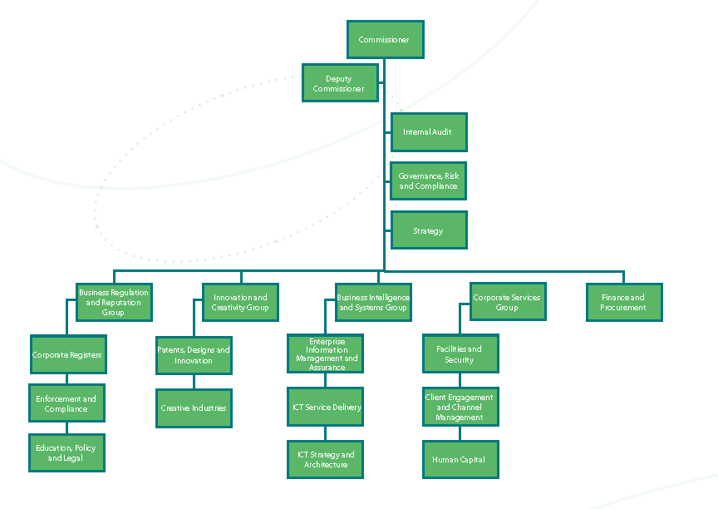***Current organizational structure***

# Project Overview

* ***PROJECT GOALS***

CIPC is engaged in a process of rapid, fundamental transformation. It is imperative for it to respond to the needs of its globalised, fast changing environment in order to both deliver value to its stakeholders and remain relevant to South Africa’s developmental and economic needs. This transformation process has to happen at the same time that CIPC delivers on its immediate imperatives - to implement a balanced regulatory regime and to serve its Customers efficiently and effectively.

In order to increase the scope of CIPC’s role in the economy (as envisaged in the Companies Act, 2008) and to play a meaningful role in the new legal dispensation impacting business entities and intellectual property in South Africa, CIPC identified, as one of its key priorities, the need to improve its credibility with Customers and other stakeholders. To give effect to this, four initiatives have been identified, namely:

* To reduce the administrative burden on businesses when they report financial information to government for regulatory compliance. Achieving this goal requires reducing duplication and inconsistency in business information reported to various government agencies—thus, a national (local) taxonomy becomes a necessity.
* To achieve regulatory compliance to accomplish the mission of the government agency. The CIPCs primary mission is to provide business and financial information to investors for better transparency rather than to reduce the administrative costs of reporting businesses.
* ***OBJECTIVES***

**Companies and Intellectual Property Commission (CIPC)** is issuing this RFI to gain a better understanding of industry best practices and vendor capabilities in addressing CIPC’s business and technology requirements. Specifically CIPC is seeking approaches, methodologies, architectures and solutions for the implementation of an eFiling Platform for Financial Statements using the eXtensible Business Reporting Language (XBRL) Standard to egress from PDF reporting format to a structured format. CIPC understands that in developing such business intelligence, the business requirements, processes and people factors are just as critical as the technical solution. Due to the complexity of implementing transformation projects such as this, CIPC is also seeking responses on vendor experiences and successes with similar projects for other regulatory clients. The responses from this RFI process may be used in the issuance of a Request for Proposal (RFP) for the procurement of the eFiling Solution using XBRL. However the issuance of this RFI does not represent a commitment to issue an RFP, award of contract. The costs of preparing this RFI will be borne by each vendor and it is not re-imbursable by CIPC.

The key long-term benefits that CIPC seeks from this proposed implementation are:

* A higher number of Financial Statements reviewed as part of proactive monitoring will be possible;
* Monitor data and activities and reach judgements with far greater speed and confidence;
* No comprehensive data entry will be necessary as part of the surveillance process. With the correct tools, an analyst can formulate ad-hoc criteria to pick up a list of companies from the database expediently. Without automation, surveillance is a very labour intensive process, prone to errors, subjective judgement and long processing time. More checking criteria would require the corresponding increase in man-effort to process. Hence, substantial cost-saving could be derived from implementing a structured language like XBRL;
* Quickly and automatically identify problems with filings;
* Benefit from the use of software in validation and analysis;
* Focus effort on analysis, decision-making and dealing with counterparties rather than on data manipulation;
* Promote efficiencies and cost savings throughout the regulatory filing process;
* Enabling more structured vigilance functions to be undertaken, such as focusing of specific areas like disclosure of certain transactions, risk-based (quantitative) monitoring based on ratios and trend analysis, analysis of measurement-related disclosures in conjunction with quantitative analysis of trends;
* Analyse and compare data much more quickly, efficiently and reliably;
* Standardisation (data stored in a non-proprietary format – longevity of data; comparability);
* Mitigation of risk – no user intervention if software used and no re-capturing, using a single standard – XBRL and non-proprietary; portable – can be used across industries);
* Provisioning for an application for automating the regulatory and supervisory system across various regulators;
* Provisioning for an application for integrating the workflow of various operational processes within the supervisory function of CIPC;
* Implementation Services;
* Support Services;
* Maintenance;
* Management information (faster, accurate, management dashboards, comparability, taxonomy (every fact is known – includes the metadata); and
* Transfer of knowledge and skills

***SCOPE OF WORK***

CIPC is seeking for qualified solution vendors that would be able to develop an efiling XBRL platforms. This would be used in detailing the Enterprise Architecture framework and describe the environment under the following domains:

* The Business Architecture domain;
* The Application domain comprising the Core and non-core Systems;
* The Data Architecture domain comprising the databases supporting the Applications;
* The Technology domain comprising the Hardware and Network supporting the Applications and data;
* The Application protocol interface (API);
* The Business Intelligence capability;
* The Management Information Systems (MIS) capability; and
* Provide comparative entities financial performance.

This is a very important project for CIPC and we are looking for a software vendor that can demonstrate their experience of having delivered these types of transformation programmes within similar organizations to CIPC. In light of the importance placed on this project we would value advice on how to set-up and prepare for this project. We would also like to understand how you could be of further assistance beyond the initial delivery. In your response please explain how you could meet these requirements.

We would expect our service provider to be able to bring innovative ideas around the use of iXBRL to enable CIPC to provide a world class service to all constituent groups. In your response please explain how you can demonstrate innovation in the area of iXBRL usage as well as the pro’s and con’s between iXBRL and XBRL

In order to achieve our objectives we need to be able to capture, validate, examine, store and interrogate all Annual Financial Statements filings that we receive. More detail of the functional requirements is provided in section 2.3 below.

**The key attributes that we are looking for when meeting our requirements:**

* Compatibility to transformation into (i.e. Oracle 10G & Informix Version 11 Database );
* Repository for retrieval, storage and access which is scalable;
* A scalable platform (provide size preferably) – flexible architecture;
* A capability to ensure that the information originally captured and processed is identical to the output and that such information is ready for consumption;
* A business reporting process that provides for transparency, traceability and protection of integrity of information;
* Security to ensure that the transaction is accessible only to the interacting parties;
* A data integrity and security that is tamper proof;
* Workflow and escalation protocols including notifications;
* Customisable reporting & analytical capability formats;
* Solution to be capable of integrating into multiple technical environments;
* Capability to ensure that iXBRL reports are validated against the recognised latest CIPC Taxonomy;
* Taxonomy versioning capability;
* Inline XBRL capability (system having to be able to provide a human readable version of a report based on HTML, the language of the web, with XBRL Tags hidden from view in the underlying file;
* XBRL Processing Engine Type (large scale processing of XBRL documents);
* XBRL Reporting Tools (Conversion Tool that can enable end-users to generate XBRL documents without prior knowledge of XBRL); and
* XBRL Rendering Tools (Rendering Tool that enables XBRL documents to be displayed as Excel templates and for data thereon to be reviewed and analysed).

CIPC is committed to adherence to the international XBRL standards and are therefore expecting any solution provider to participate in these standards and to bring best practices and experience of these standards to our project. Over time our data model will change and evolve so it is important that any solution that’s implemented is able to support this evolution of our data model, and is able to cope with taxonomy changes which would be prone to the below:-

* Comprehensive approach;
* Cost-saving (mid-long);
* Control over result;
* Automated processing;
* Enhanced reporting; and
* High data quality.

In addition to changes to the data model, it is also likely that there will be a need for us to modify the rules we implement for filers and so we will also need a solution that can grow and adapt with any rule changes we may require.

Once the data has been captured it is important that the data is available quickly and that we can interrogate the data without the need to resort to cumbersome data warehouses.

**Information needed from the supplier**

**VENDOR DETAILS FOR THIS RFI**

The vendor should identify their products and service offerings that address the issues raised under scope, and define their solutions based on its capability as detailed below:

* Platform for processing XBRL (iXBRL) based reporting;
* Assurance services;
* Data analytics platform;
* Auditability platform;
* Mapping engine; and
* Rendering engine.

Vendors should explain how their product, services or solution meets the specific requirements documented here. Vendors should not respond by simply attaching stock product or service brochures. At this RFI stage, the CIPC will consider information from vendors who are able to deliver the whole solution or any of the major components or activities. The vendor must clearly identify the scope offered in their response if they are unable to deliver the entire solution. Vendors can provide alternative structures of the solution or delivery approach if they deem them to be more appropriate.

The below diagram depicts the implementation plan and what is in and out of scope:

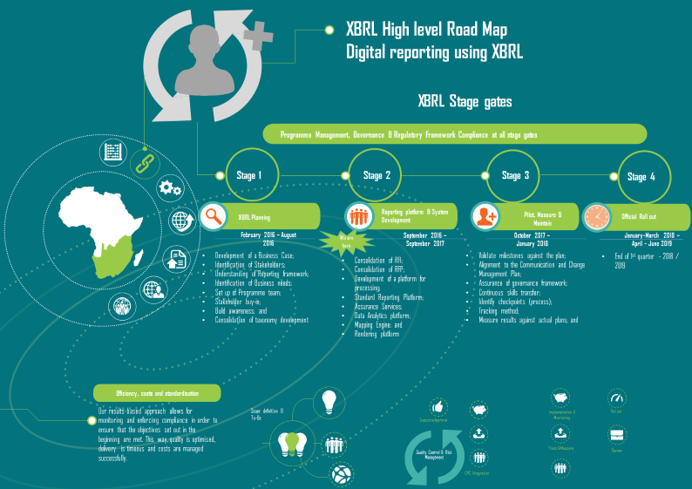

**RECOMMENDED APPROACH**

Provide in your response your understanding of the solution requirements listed in this RFI, and based on your experience, your recommended approach and the key issues in implementing your proposed solutions. This includes any Enterprise Architecture (EA) framework, application development approaches or COTS (Commercial off the Shelf) solutions for all solutions you can provide when a detailed RFP is provided. CIPC would like software vendors to offer suggestions as to implementation time frames, number of resources required and recommended support available from the vendor after start of operations, such as online website, toll free numbers and helpdesk support.

**SUPPLIER’S VIABILITY AND CAPABILITY**

Provide in your response references to equivalent IT Solution implementations and include which of the solutions listed in your response are included in those references. Include information such as solutions provided and implementation time frames. In order to proceed further with any vendor providing information in response to this RFI, CIPC must be assured of their financial strength, stability and continuing viability.

* ***EXPECTED SERVICE DELIVERY***

## Structure of the document

The following outline is offered to assist in the development of your response. You should include:

* A cover letter - the cover letter should include a brief summary of your response, such as indicating to which areas you are responding and must also indicate if supporting documentation is included in your response.
* The response itself, must cover any or all of the areas of information requested by this RFI. The information should be provided so that the evaluation against the Issues raised and the Solution Requirements is facilitated easily.
* If required, provide a glossary that maps terminology used in your response to CIPC’s standard terminology as contained in this RFI.

Although CIPC does not limit the size of responses, you are asked to consider limiting the size of your response (not counting any supporting documentation) to approximately 50 pages. If you consider supporting documentation to be necessary, please indicate which portions of the supporting documentation are relevant to this RFI.

## RFI schedule

### Liabilities of CIPC

This RFI is only a request for information about potential products / services and no contractual obligation on behalf of CIPC whatsoever shall arise from the RFI process. This RFI does not commit CIPC to pay any cost incurred in the preparation or submission of any response to the RFI.

### Confidentiality & RFI Ownership

This RFI is both confidential and proprietary to CIPC, and CIPC reserves the right to recall the RFI in its entirety or in part. Software vendors cannot and agree that they will not duplicate, distribute or otherwise disseminate or make available this document or the information contained in it without the express written consent of CIPC.

Software vendors shall not include or reference this RFI in any publicity without prior written approval from the client, which, if granted, shall be granted by the individual named above. Basic partners must accept all of the foregoing terms and condition s without exception. All responses to the RFI will become the property of CIPC and will not be returned.

## Functional Requirements

CIPC is considering to implement a solution for producing, validating and processing iXBRL reports in-line with international accounting (IFRS) and technical standards (XBRL).

In order to deliver the above components the solution must be built using commercial, off-the-shelf (COTS) products. iXBRL experience is also a mandatory requirement. We understand that there are a number of different ways in which this type of solution can be implemented. With this in mind we would like some guidance on the technical considerations we should pay attention to?

In light of the above, CIPC is seeking for a solution to capture, validate, examine, store and interrogate all filings that are submitted. For each of these functional areas please provide the following:

* A description of the possible methods available to CIPC; and
* A description of your preferred method of delivery.

The system should be available at all times during the business working day so we would expect an availability of a minimum of 99.5%. This figure takes into account any routine maintenance slots which may be required.

The solution provider should ensure that the solution can:

* Convert documents into validated iXBRL for filing of reports. This conversion process should have the ability to automate much of the filing process and to assist the filer in creating valid and consistent reports;
* capability of receiving and processing the iXBRL and to render reports into other formats for downstream processing (e.g. a SQL database);
* Create a repository of filings which will form the basis of a business intelligence solution. The business intelligence solution should be able to “mine” the reports repository to provide insights into the information held;
* The business intelligence solution should be aware of the structure of the reports in the repository and therefore enable a wide variety of searches and queries. It should also be possible to identify reporting practices which may be flawed in order to provide feedback to filers to enable us to ensure the quality of the data in the repository;
* The complete solution must be flexible in order to be able to cope with taxonomy changes without the need for development work either by the supplier or by CIPC. This means that the production and business intelligence aspects of the solution should have little impact on the existing taxonomy to be able to adapt to any changes;
* It is vitally important that the production and business intelligence parts of the solution are “user friendly” and simple to use since the target audience will be business users and therefore should not be expected to have in-depth technical skills;
* The solution providers should provide what they think is the best implementation approach after the system has been tested and ready to be rolled out. This should be clearly articulated in the “Big Bang” or “Phased” adoption by filers to CIPC;
* The solution vendor should have the ability to develop a filing manual for external software vendors to comply with when submitting the filings after preparation of entities financial statements and marked into iXBRL;
* The software vendors should also provide their input as to CIPC “Approving” these software vendors as being able to file into the CIPC efiling platform; and
* The solution should provide assurances with the accuracy of the outputs.

**The below are the components required when developing the solution:**

* A Filing submission solution to enabled:
  + Submission of iXBRL reports by filing organisations; and
  + Cross period consistency checks.
* The filing portal should be scalable and make use of industry standard interfaces.
* An iXBRL processing solution
  + Validation of filings;
  + Rendering of filings; and
  + Assurance of fillings.
* A solution to help filers to create (“minimum tagging”) iXBRL documents ready for submission.
  + Conversion of source documents (html) to iXBRL;
  + Automated tagging of information in accordance with the taxonomy;
  + User assistance when processing documents;
    - Recommended tags;
    - Bulk tagging;
    - Validation against filing rules; and
    - Generate validated iXBRL.
  + Process should enable quick and accurate filings.
* A Storage and retrieval capability:
  + A repository of iXBRL documents;
  + Possibility to export iXBRL to other formats (e.g. SQL database);
  + An adaptable, scalable business intelligence platform for deeper analytics;
* An end-user tool to enable access to the iXBRL repository
  + Easy to use;
  + User defined queries;
  + Stored queries;
  + Search iXBRL tagged data; and
  + Search untagged data.
* An end-user tool to enable viewing of iXBRL documents:
  + View tagging;
  + Document comparison (e.g. year on year comparisons);
  + Standardized XBRL view;
  + Searching; and
  + Direct links to taxonomy metadata.
* Ability to manage taxonomies:
  + Data modelling;
  + Taxonomy maintenance;
  + Taxonomy quality assurance; and
  + Facilities for public and private rules.

## Optional requirements

Our chosen software vendor must be able to provide comprehensive customer support backed by robust incident tracking and handling processes and procedures. The solution provider will have to sign a service level agreement. This is a key requirement since CIPC must maintain and enhance its reputation for quality with its customers. Users must be able to contact the support desk by email and telephone as a minimum and the help desk must be available during normal business hours.

## INFORMATION Security Requirements and privacy protection

We need to be able to guarantee the privacy and security of all of our data and so it is vital that the chosen vendor has policies and procedures in place to ensure this. It is also vital that proper protection is in place in terms of user authentication, virus protection and other kinds of security breach. Please explain your deployment model, in particular which elements of your solution are on-premise and/or cloud based.

## legal requirements

The material contained in this document is proprietary to CIPC, and is released for informational purposes only. No rights in said material are hereby transferred to any other organization. This material may not be disclosed, duplicated, or otherwise revealed, in whole or in part, without the written consent of CIPC and is subject to the terms of the *Non-Disclosure Agreement* executed by vendor and CIPC.

By agreeing to respond to this RFI, the software vendor expressly acknowledges that CIPC business procedures, ideas, inventions, plans, financial data, contents of the RFI, and other CIPC information are the sole and exclusive property of CIPC. The vendor also agrees that it will safeguard such information to the same extent as it safeguards its own confidential material or data relating to its own business information that is of confidential or proprietary nature. The software vendor shall not furnish the name of CIPC or any of the affiliated CIPC companies, as a reference or use the name of CIPC or any of the affiliated companies in any advertising or promotional materials without the prior written consent of CIPC.

## Response Format

**Information about the basic partners and the potential product / service.**

| **Question** | **Response** |
| --- | --- |
| Partner name  Parent company |  |
| Partner address |  |
| Name of person responsible for the information contained in this RFI |  |
| **Telephone number:**  Fax number  Email address  Web page |  |
| Initial year of operations |  |
| **Partner location:**  Corporate office  Local offices (RSA)  Other office |  |
| **Number of employees:**  Total  Development  Implementation  Sales & administration support  Employee turnover rate  Employee satisfaction (if surveyed and known)  Key employees (names and terms of contract) |  |
| **Total revenue:**  Current year  Previous year  Total profit/loss  Current year  Previous year |  |
| **Disaster Recovery/Business Continuity:**  Give details of your business continuity arrangements. |  |
| **South Africa Business Strategy:**  Give details of your strategy for doing business in South Africa especially in relation to your growth plans for the region over the next 2 – 5 years. |  |
| **Experience and Capabilities:**  Please outline your experience within the arena international standards (XBRL and IFRS) and with regulatory bodies. Please explain your capabilities and experience of iXBRL.  Regulatory environments  Please explain how you have worked with other regulators.  Which solutions have you implemented with other regulators?  Volume of filings  What is a typical number of filings your solution manages a year?  What are the peak volumes of filings you have managed?  How much bandwidth would the system require? |  |
| **Standards support:**  Please list the standards which your solution can support.  What is your policy for supporting new, in-progress or existing standards? |  |
| **Companies and References:**  Have you supplied to customers in a similar industry, with a similar growth profile that would act as a reference site for you? If so then please state them |  |
| **Depth of Experience:**  Total number of installations of the version of the software being proposed, which have been carried out by your organization? |  |
| **Partnerships and Alliances:**  Describe any third party alliances/relationships |  |
| **Legal Actions:**  Please provide details of any outstanding legal action against your company or any directors or partners. |  |
| **Mergers and Acquisitions:**  Are there any anticipated mergers or acquisitions pending? |  |
| **Project Preparation, Delivery and Post Project Support**:  How would you help us to prepare for this project, what services can you provide to ensure a proper foundation prior to embarking on the project.  Please provide information on your implementation methodology.  Please provide a project roadmap indicating key stages and key milestones.  Please provide an example project plan with timelines.  How would you help to manage and support us through the life of this project?  How can you demonstrate innovation in the area of iXBRL usage?  What follow on services can you provide to ensure that we can continue to extract the best value from your solution after the initial project completion? | Attach as required. |
| **Documentation:**  What documentation is provided for the software / system? |  |
| **Software/Architecture:**  Was your software written by your organization or acquired from a third party?  Is your software written according to appropriate industry standards, please provide details?  Please provide a diagram of the components which make up your proposed solution, this should include a brief description of what each component does.  Please provide a diagram showing the process flow of your solution, this can be included in the component diagram if appropriate.  Please describe how your software would be able to integrate with existing CIPC systems if required.  Is your software compatible with Microsoft Office solutions (Excel, Word)?  How long has your software been available in the marketplace?  What are the key strengths and weaknesses of your software? |  |
| **Performance:**  Describe your scalability model (horizontal, vertical, load-balancing), availability (fault tolerance, clustering), and performance (messages, transactions, work flows) for all application components. |  |
| **Testing of the solution:**  Pleas describe the solution in detail outlining your approach to testing this before rollout extensively. Conduct the functional tests, approach to functional testing, taxonomy testing, performance and stress testing, etc.  **Training:**  Describe your training methodology for preparers?  Do you offer formal user training?  What type of courses do you run and what is their duration?  What level of training would you recommend?  Describe any training materials offered? |  |
| **Product Support:**  Please provide details of how the product is supported across multiple sites globally.  What levels of support is available, definition of each level and what are the hours of operation and response times?  Where are the support services located?  Does support include product updates, as well as bug fixes at no extra charge?  What is the helpdesk escalation procedure? |  |
| **Project Costs:**  Please summarize the total costs of your product.  What are the licensing costs for individual parts of the solution?  Are new releases chargeable separately?  What are your consultancy rates to help with implementation?  What do you charge for customization?  What do you charge for training?  What are the maintenance and support costs? Please give a breakdown.  Do you offer discounts for volume purchases?  Do you levy any charges for software or services during the evaluation period? |  |