

**USAID Financial Sector Transformation - FST**

Request For Proposals (RFP)

No. REQ-KYV-18-0137

Financial Reporting System based on XBRL instance documents

for Ukrainian Financial Regulators

Issue Date: May 2, 2018

**WARNING**: : Prospective Offerors who have received this document from a source other than the USAID Financial Sector Transformation Project 33B, Taras Shevchenko boulevard, Europe Plaza Business Center, 6th floor Kyiv, Ukraine, 01032, [ProcurementFST@dai.com](mailto:ProcurementFST@dai.com), should immediately contact [PocurementFST@dai.com](mailto:PocurementFST@dai.com) and provide their name and mailing address in order that amendments to the RFP or other communications can be sent directly to them. Any prospective Offeror who fails to register their interest assumes complete responsibility in the event that they do not receive communications prior to the closing date. Any amendments to this solicitation will be sent to all registered participants by e-mail.

Table of Contents

1. Introduction and Purpose 3

1.1 Purpose 3

1.2 Issuing Office 4

1.3 Background 4

1.4 Type of Award Anticipated 5

2. General Instructions to Offerors 5

2.1 General Instructions 5

2.2 Proposal Cover Letter 6

2.3 Questions Regarding the RFP 6

3. Instructions for the Preparation of Technical Proposals 6

3.1 Goods or Services Specified 10

3.2 Technical Evaluation Criteria 10

4. Instructions for the Preparation of Cost/Price Proposals 11

4.1 Price Schedule 11

4.2 Price Evaluation Criteria 12

4.3 Combined Evaluation 12

5. Responsibility Determination 12

5.1 General Responsibility 12

5.2 Data Universal Numbering System (DUNS) 12

6. Basis of Award and Selection Process 13

6.1 Basis of Award 13

6.2 Selection Process 13

7. Anticipated post-award Deliverables 13

8. Inspection & Acceptance 15

9. Compliance with Terms and Conditions 16

10. Procurement Ethics 16

11. Proposal checklist 16

12. Attachments 18

Attachment A: Scope of Work and Technical Specifications 19

A.1 Business context 19

A.2 Overall system description 20

A.3 System Requirements 21

A.4 Expected system parameters and volumes 61

Attachment B: Proposal Cover Letter 62

Attachment C: Price Schedule 63

Attachment D: Instructions for Obtaining a DUNS Number - DAI’S Vendors, Subcontractors 65

Attachment E: Self Certification for Exemption from DUNS Requirement 74

Attachment F: Representations and Certifications of Compliance 75

Attachment G: Full Terms of Contract 76

Synopsis of the RFP

|  |  |
| --- | --- |
| RFP No. | REQ-KYV-18-0137. |
| Issue Date | May 2, 2018. |
| Title | Financial Reporting System based on XBRL instance documents for Ukrainian Financial Regulators. |
| Issuing Office Physical Address | USAID Financial Sector Transformation Project, 33B, Taras Shevchenko Boulevard, Europe Plaza Business Center, 6th floor Kyiv, Ukraine, 01032. |
| Deadline for Receipt of Questions | Questions regarding RFP requirements should be submitted electronically via email to [ProcurementFST@dai.com](mailto:ProcurementFST@dai.com) not later than May 16, 2018, 6 PM local time. |
| Deadline for Receipt of Proposals. | Final proposals should be submitted electronically in PDF format via email to DAI no later than June 5, 2018 by 6 PM local time to the following address [ProcurementFSTInbox@dai.com](mailto:ProcurementFSTInbox@dai.com) |
| Contact | [ProcurementFST@dai.com](mailto:ProcurementFST@dai.com) |
| Anticipated Award Type | Firm Fixed Price Subcontract. |
| Basis for Award | An award will be made based on the Trade Off Method. The award will be issued to the responsible and reasonable offeror who provides the best value to DAI and its client using a combination of technical and cost/price factors. |

# Introduction and Purpose

## Purpose

DAI, the implementer of the Financial Sector Transformation (FST) Project, invites qualified offerors to submit proposals to develop, install and implement the Financial Reporting System based on XBRL instance documents for Ukrainian Financial Regulators in support of Project implementation.

On December 18, 2017, the National Securities and Stock Market Commission, the National Bank of Ukraine, the National Commission for Regulation of Financial Services Markets and the Ministry of Finance of Ukraine (together, the “Participating Regulators”) signed a Memorandum of Understanding for the development and implementation of a Financial Reporting System.

The National Securities and Stock Market Commission (NSSMC) is the regulator of the market of securities and other financial instruments in Ukraine.

The Financial Reporting System will be managed by the NSSMC, acting as a hub for the collection of audited financial statements from the reporting entities, the validation of reported data and the distribution of the information to the involved participant regulators. The other financial regulators to use the reporting system include the National Bank of Ukraine, the National Commission on State Regulation of Financial Services Market (NCSRFSM), the Ministry of Finance, and possibly others.

## Issuing Office

The Issuing Office above is the sole point of contact at DAI for purposes of this RFP. Any prospective Offeror who fails to register their interest with this office assumes complete responsibility in the event that they do not receive direct communications (amendments, answers to questions, etc.) prior to the closing date.

## Background

The USAID funded Financial Sector Transformation (FST) Project aims to increase public confidence in, understanding of, and use of the banking system; transform the non-bank financial sector regulatory environment, including the Ukrainian capital markets; increase access to finance for small businesses and financial inclusion; expand financial inclusion through enhanced digital finance; and support a balanced and sustainable pension system. Primary focus area of this procurement is to support Ukrainian capital markets.

One of the key objectives in the reform of the Ukrainian economy is the need to improve the transparency and reliability of the financial statements for both private and public enterprises.

The lack of transparency of financial information represents a main constraint for local and foreign partners for investing or establishing partnership agreements with Ukrainian companies. It also limits the efficacy of the activity of regulatory bodies in preventing financial instability and unfair market practices.

The Financial Reporting System is expected to be an integrated system allowing the reception, processing, validation and disclosure of financial statements from reporting entities and their audit reports, ensuring market transparency and information disclosure by market participants.

The Financial Reporting System should be **based on XBRL or Inline XBRL instance documents, prepared according to** Ukrainian IFRS 2018 Taxonomy.

**The general business requirements of the Financial Reporting System are the following:**

* The system must allow the reception of XBRL or Inline XBRL instance documents, prepared by the reporting entities, according to the XBRL taxonomies defined by the NSSMC, or XML documents.
* The system must allow the processing and validation of XBRL or Inline XBRL instance documents, based on the validation rules defined by the NSSMC.
* The system must allow extracting the data from XBRL or Inline XBRL instance documents and store the financial information in a staging area.
* Based on the type of reporting entity the financial data will be extracted to the internal data warehouse of the NSSMC and/or sent to the regulators responsible for the specific reporting entity.
* The information corresponding specifically to the scope of activity of each Participant Regulator will not be possible to be accessed by other regulators.
* The system must provide external users of the participating regulators the ability to monitor the status of the fulfilment of reporting requirements of their reporting entities.
* The system must provide filers with the possibility to check the current status of their submissions.
* The system must allow external users to access financial information of market participants following the disclosure rules defined by the NSSMC, in a consistent, human-readable image of the structured data in XBRL or Inline XBRL format.
* The system must support multilingual labels with specific support for the Ukrainian language, including application system elements (screens, reports, error messages, etc.).
* The system must follow state of the market international best practices in data management, development and maintenance, disaster recovery, efficiency, reliability, security, usability and other operational requirements for a financial services regulator.

## Type of Award Anticipated

DAI anticipates awarding a Firm Fixed Price Subcontract. This is only the anticipated type of award and may be changed as a result of negotiations.

A Firm Fixed Price Subcontract is: An award for a total firm fixed price, for values more than $150,000, for the provision of specific services, goods, or deliverables and is not adjusted if the actual costs are higher or lower than the fixed price amount. Offerors are expected to include all costs, direct and indirect, into their total proposed price.

# General Instructions to Offerors

## General Instructions

Proposals are due no later than June 5, 2018, 6 PM local time, to be submitted electronically via email to [ProcurementFSTInbox@dai.com](mailto:ProcurementFSTInbox@dai.com). The RFP number (REQ-KYV-18-0137) and title of the activity “Financial Reporting System based on XBRL instance documents for Ukrainian Financial Regulators” must be stated in the subject line of the email. Cost and technical proposals shall be submitted in separate files. Late offers will be rejected except under extraordinary circumstances at DAI’s discretion.

DAI reserves the right not to evaluate a non-responsive or incomplete proposal.

The completion of all RFP requirements in accordance with the instructions in this RFP and submission to DAI of the proposal will constitute an offer and indicate the Offeror’s agreement to the terms and conditions in this RFP and any attachments hereto.

DAI reserves the right to award a subcontract without discussion and/or negotiation; however, DAI also reserves the right to conduct discussions and/or negotiations, which among other things may require an Offeror(s) to revise its proposal.

Issuance of this RFP in no way obligates DAI to award a subcontract or purchase order.

DAI reserves the right to award subcontract for some items in the proposal or to change the amount of required services.

**All documents from the Offeror related to this RFP shall be in English**.

Offerors will not be reimbursed for any costs associated with the preparation or submission of their proposal. DAI shall in no case be responsible for liable for these costs.

Offerors are required to fully review all instructions and specifications contained in this RFP. Failure to do so will be at the Offeror’s risk.

Offerors shall confirm in writing that the Offeror fully understands that their proposal/offer must be valid for a period of 120 calendar days. Time is stated in calendar days, unless otherwise specified.

If the solicitation is amended, then all terms and conditions not modified in the amendment shall remain unchanged. Offerors shall acknowledge receipt of amendments in the cover letter.

Offerors shall:

1. Furnish all of the information required by the RFP;
2. Ask any questions to clarify the requirements if necessary;
3. Sign and submit the cover letter;
4. Use and submit forms as provided in the Attachments as required.

“Offeror”, “Subcontractor”, and/or “Bidder” means a firm proposing the work under this RFP. “Offer” and/or “Proposal” means the package of documents the Offeror submits to propose the work.

## Proposal Cover Letter

**A cover letter shall be included with the proposal on the Offeror’s company letterhead with a duly authorized signature and company stamp/seal using Attachment B as a template for the format.** The cover letter shall include the following items:

* The Offeror will certify a validity period of 120 calendar days for the prices provided.
* Acknowledge the solicitation amendments received
* Acknowledge that DAI reserves the right to award subcontract for some items in the proposal or to change item quantities in the award process for both hardware and for software licenses.

## Questions Regarding the RFP

Each Offeror is responsible for reading very carefully and understanding fully the terms and conditions of this RFP. All communications regarding this solicitation are to be made solely through the Issuing Office. Requests for clarification or additional information must be submitted via [ProcurementFST@dai.com](mailto:ProcurementFST@dai.com) to the Issuing Office no later than the date and time specified in the Synopsis above. Only written communications relative to the procurement shall be considered. No questions will be answered over the phone or in person. The subject line of the email or the heading of the letter must include the RFP Number and Title.

Questions and requests for clarifications – and the responses thereto – that DAI believes may be of interest to other Offerors will be circulated in writing to all RFP recipients who have indicated interest in responding to this RFP. Both questions and answers will be distributed, without identification of the inquirer(s), to all prospective Offerors who are on record as having received this RFP. Any verbal information received from a DAI or FST employee or other entity shall not be considered as an official response to any question regarding this RFP.

# Instructions for the Preparation of Technical Proposals

Technical proposals shall be sent in a separate file from cost/price proposals, and shall be clearly labeled as “VOLUME I: TECHNICAL PROPOSAL”.

Technical proposals shall consist of the following sections:

1. **Section A. Presentation of the Offeror**, including completed Form A.1 presented in this section below.

2. **Section B. Past performance**, including completed Form A.2 presented in this section below.

3. **Section C. Description of the proposed solution**.

4. **Section D. Requirements compliance form**, including completed Forms A.3.1 – A.3.3 presented in Attachment A of this RFP.

5. **Section E. Methodology and work plan**.

6. **Section F. Project team**.

А detailed description of the contents of sections A-F is given below

Section A. Presentation of the Offeror

This section should describe the main characteristics of the prime contractor and subcontractors participating in the proposal, including the distribution of roles and responsibilities for delivery, and information on legal or contractual arrangements. **Form A.1 below must be completed.**

**Form A.1.**

|  |  |  |
| --- | --- | --- |
| Is your organization bidding in the role of prime contractor and intends to use third parties to provide some services? | Yes, we intend to use subcontractors  No, all services will be directly delivered by the company | |
| If yes, indicate the name of the subcontractors involved, their role in the project and the estimated percentage of the requirements they will directly deliver | | |
| Name of organization | Role in the project | % of the requirements to deliver |
|  |  |  |
|  |  |  |
| Please indicate the specific role and tasks of the prime contractor in the delivery of the products and services | | |
| Roles / tasks of the prime contractor in delivering the products and services | | % over the total requirements to deliver |
|  | |  |
|  | |  |
|  | |  |
| Has the prime contractor formalized in a contract / agreement the participation of all the subcontractors in the potential tender and their role in the project delivery? | | |
| Formalization of subcontracting agreements | Yes / no / partially | |
| If yes, please describe the way in which the responsibilities have been defined and fixed. |  | |
| Is there any pending, current or previous (during the last 5 years) litigation or other legal proceedings connected with similar projects against the Offeror and/or any of its sub-contractors that may affect delivery of this project? | Yes / no | |
| If yes, please describe |  | |

Section B. Past Performance

Provide information of similar projects performed during the last five years for financial market regulators, identifying those specifically done for securities and exchange commissions. Please indicate in the following Form a description of projects performed, the legal name, address and a current contact phone number of a responsible and knowledgeable representative of the organization for which services were performed, the value of the contract, start and end dates of the project, and other information requested.

**Form A.2.**

|  |  |  |  |  |  |  |  |  |
| --- | --- | --- | --- | --- | --- | --- | --- | --- |
| # | Project Title | Description of Project | Client  Legal Name / Address / Contact Tel. No | Cost in US$ | Start-End  Dates | Completed on schedule  (Yes/No) | Completion Letter Received?  (Yes/No) | Type of Agreement, Subcontract, Grant, PO (fixed price, cost reimbursable) |
| 1 |  |  |  |  |  |  |  |  |
| 2 |  |  |  |  |  |  |  |  |
| 3 |  |  |  |  |  |  |  |  |

Section C. Description of the proposed solution

In this section, the Offeror will describe the key features of the solution or solutions to be delivered, the system architecture and the detailed technical environment required for the implementation and to put into operation the solution.

Description of technical environment should include:

1. Explicit description of the proposed product‘s systems hardware requirements to keep up to the expected volumes and performance.
2. Explicit description of the proposed product‘s systems software requirements, including operation system and data base management system (DBMS).
3. Explicit description of all proposed solution interface technologies requirements (for example: SOAP, REST, PKI, etc.).
4. Explicit description of the XBRL processor needed to keep up to the expected functionality, volumes and performance, including the following:
   * is this the Offeror’s own XBRL suite,
   * is it bundling a third party commercial processor,
   * is it integrating an open-source alternative whose support is included in the vendors maintenance commitment.

Section D. Requirements compliance form

**This section must include completed Forms A.3.1 – A.3.3 presented in Attachment A of this RFP**, providing individual responses to each of the requirements of the information system to be supplied.

Section E. Methodology and work plan

The Offeror shall describe in this section the methodology to be applied in all the stages of the project, the way of ensuring a full understanding of user requirements, change management methods to be applied, testing procedures and the detailed work plan for the project.

The Offeror should detail the project plan to implement the system. The project plan should be structured in such a way that enables control over the progress of the solution components prior to the acceptance tests phase. The project plan will include:

* Project milestones.
* Project breakdown structure of main tasks and detailed tasks that includes at least:
  + Detailed development plans
  + Training Plan
  + Migration and Go live plan
* Task dependencies and critical path.
* Task duration and estimated target dates of completion

The acceptance test of the system should be satisfactory completed no later than 6 months after project kick off date.

The Offeror must appoint a project team, led by a Project Manager on their behalf. This project manager should present and defend the providers proposal. (same person during the tender and the project itself.

The Offeror’s Project Manager will manage the project from start to finish, and will be the point of contact between NSSMC and all parties involved in the project on behalf of the provider. He will have more than 8 years of experience in managing complex IT implementation projects in the financial sector.

The project team should include the participation of an XBRL Implementation Expert with proven experience in managing at least 3 XBRL implementation projects performed within the last 6 years.

The Offeror should specify in his offer the composition of the project team, including the description of roles, the curriculum vitae of the team members and their dedication on site and off site.

The Offeror should prepare an Acceptance Test Plan that will be discussed and approved by the NSSMC. Acceptance Test Plan will include all aspects of the system including the aspect of information security and access controls.

Acceptance testing will be performed by DAI, the NSSMC and the Offeror will accompany and support them in carrying out these tests in full, including preparation of work environments for testing, preparation of test cases and integration testing.

During acceptance testing, the parties will list all the defects (software or other findings including noncompliance with response times). When defects are discovered, the provider will fix the defects without impacting the project timetables and expenses.

After defects are fixed there will be an additional testing cycle to ensure that all defects were corrected in a satisfactory manner.

After completion of acceptance testing and repairing of any faults, DAI and the NSSMC will issue a written confirmation of completion of acceptance testing.

All project documentation will be provided by the Offeror in English and Ukrainian.

Project documentation includes but not limited to: user guides, operational guides, technical documentation, customization developments, test plans, training materials, user guides, project plans, and any other correspondence with NSSMC regarding the project.

The documentation must be delivered no later than the end of the Acceptance Test phase.

The final version of the documentation must be up to date, and delivered no later than go live date.

The Offeror must include in his offer the plan concerning knowledge transfer and training describing in detail all required training modules and suggested duration of each training module.

The training should include both business and IT training. The training should give the users and IT personnel the required knowledge to operate and handle the system in a correct and efficient manner.

The Offeror is responsible for the transition period, when moving from development and test environments to production environment.

The Offeror shall provide onsite support to the NSSMC in all the activities required for the migration and going live of the new system.

The Offeror will specify in a Migration and Going Live Plan the detailed activities, schedule and team members that will be present on site during this transition period.

Section F. Project team

This section shall detail the composition of the project team that the Offeror will assign to the project, the description of roles, expected dedication on site during the project and the CVs of the proposed candidates. CVs are limited to three (3) pages per individual.

## Goods or Services Specified

For this RFP, DAI is in need of the services and software licenses described in detail in Attachment A.

Final delivery is required by December 31, 2018.

## Technical Evaluation Criteria

Each proposal will be evaluated and scored against the evaluation criteria and evaluation sub-criteria, which are stated in the tables below. In the evaluation of Technical Proposals, the members of the Committee will apply the following criteria:

* Profile and experience of the Offeror to perform the project
* Prime contractor/subcontractor relationship
* Compliance of the proposed solution with the list of requirements
* Soundness of implementation approach proposed.

For each Offeror, the committee will assign an individual score referred to each of the criteria. The scores will be assigned according to the following table, in order to calculate an overall score for each provider:

|  |  |
| --- | --- |
| **Criteria** | **Maximum score** |
| **Profile and experience of the Offeror:**   * Offeror corporate and operational standing; * Soundness of subcontracting structure; * Experience in XBRL reporting; * Experience with financial services regulators.   *\* Profile and experience of the Offeror will be evaluated based on Sections A and B of the Technical Proposal.* | 20 |
| **Compliance with requirements:**   * Overall soundness of proposed solution; * Functional requirements; * Non-functional requirements; * Technical environment; * Maintenance and support services requirements.   *\* The compliance of the proposed solution with the requirements will be made based on the information provided by the Offeror in Section C and D of his Technical Proposal.* | 50 |
| **Implementation approach:**   * Methodology and work plan; * Project team; * Acceptance test; * Documentation; * Training; * Migration and go live support.   *\* The evaluation of the implementation approach will be made based on the information provided by the Offeror in Sections E and F of his Technical Proposal.* | 30 |

The evaluation score for Functional, Non-functional, and Maintenance and Support Services Requirements will be based on a matrix composed of two factors:

* + The Offeror response provided regarding the fulfilment of the requirement
  + The quality of the response description provided by the Offeror

The categories associated to these factors are described in Attachment A of this RFP.

The evaluation score for other requirements will be based on the quality of the response description provided by the Offeror.

# Instructions for the Preparation of Cost/Price Proposals

## Price Schedule

Cost/Price proposals shall be sent in a separate file from technical proposals, and shall be clearly labeled as “VOLUME II: COST/PRICE PROPOSAL”.

**Provided in Attachment C is a template for the Price Schedule.** Offerors shall complete the template including as much detailed information as possible.

It is important to note that Value Added Tax (VAT) shall be included on a separate line, and that delivery cost and total delivery cost are included on their designated budget line.

These products or services may be eligible for VAT exemption under the DAI prime contract. The Subcontractor is responsible for all applicable taxes and fees, as prescribed under the applicable laws for income, compensation, permits, licenses, and other taxes and fees due as required.

## Price Evaluation Criteria

Once the Evaluation Committee has reach an agreement on the score assigned to each Offeror in the evaluation of the Technical Proposal, the Committee will open the Cost/Price Proposals of the Offerors.

If any of the Cost/Price Proposals do not match in its presentation with the instructions indicated in this RFP, the Committee may at his own discretion, either exclude the Offeror from the evaluation or send a communication to the Offeror asking for the correction, within a timeframe, of the error or omission detected.

The Cost/Price Proposals will be scored as following:

- the lowest proposal is scored with 100 points

- scores for all other proposals are calculated as 100 * (price of the lowest proposal / price of the evaluated proposal)

## Combined Evaluation

The Evaluation Committee will calculate the final score of each Offeror assigning the following scores to the technical and financial scores combined:

|  |  |
| --- | --- |
| **Criteria** | **Weighting** |
| Technical evaluation | 70% |
| Financial evaluation | 30% |

The Offeror which provides the Best Value will be awarded to deliver the software licenses and perform the services.

The result of the evaluation will be communicated to all the Offerors.

# Responsibility Determination

## General Responsibility

DAI will not enter into any type of agreement with an Offeror prior to ensuring the Offeror’s responsibility. When assessing an Offeror’s responsibility, the following factors are taken into consideration:

1. Provide a copy of the required business licenses (if applicable).
2. Evidence of a DUNS number (explained below and instructions contained in the Attachment).
3. Having adequate financial resources to deliver goods or services or the ability to obtain financial resources without receiving advance funds from DAI.
4. Ability to comply with required or proposed delivery or performance schedules.
5. Have a satisfactory past performance record.

## Data Universal Numbering System (DUNS)

There is a **mandatory** requirement for your organization to provide a DUNS number to DAI. The Data Universal Numbering System is a system developed and regulated by Dun & Bradstreet (D&B) that assigns a unique numeric identifier, referred to as a "DUNS number" to a single business entity. Without a DUNS number, DAI cannot deem an Offeror "responsible" to conduct business with and therefore, DAI will not enter into a subcontract/purchase order or monetary agreement with any organization. The determination of a successful Offeror/applicant resulting from this RFP is contingent upon the winner providing a DUNS number to DAI. Offerors who fail to provide a DUNS number will not receive an award and DAI will select an alternate Offeror.

All U.S. and foreign organizations, which receive first-tier subcontracts/ purchase orders with a value of $25,000 and above **are required** to obtain a DUNS number prior to signing of the agreement. Organizations are exempt from this requirement if the gross income received from all sources in the previous tax year was under $300,000. DAI requires that Offerors sign the self-certification statement if the Offeror claims exemption for this reason.

**For those required to obtain a DUNS number, see Attachment D - Instructions for Obtaining a DUNS Number - DAI’S Vendors, Subcontractors**

**For those not required to obtain a DUNS number, see Attachment E: Self Certification for Exemption from DUNS Requirement.**

# Basis of Award and Selection Process

## Basis of Award

DAI will review all proposals, and make an award based on the technical and cost evaluation criteria stated above, and select the Offeror whose proposal provides the best value to DAI. DAI may also exclude an offer from consideration if it determines that an Offeror is "not responsible", i.e., that it does not have the management and financial capabilities required to perform the work required.

Cost will primarily be evaluated as stated above. DAI may award to a higher priced Offeror if a determination is made that the higher technical evaluation of that Offeror merits the additional cost/price.

DAI may award to an Offeror without discussions. Therefore the initial offer **must contain the Offeror’s best price and technical terms.**

## Selection Process

All proposals shall be received and remain unopened until the due date. All proposals shall be stored in a secure dedicated email account. On the due date, all proposals shall be opened by the Procurement Officer and shall be witnessed by at least one other project employee.

DAI may contact Offerors to seek clarification to proposal submissions that are insufficient or need to be further elaborated. Competitive Range Offerors may then be contacted to answer questions, negotiate and discuss offers, and potentially be asked to submit a “Best and Final Offer.” Upon receiving all Best and Final Offers (if a Best and Final Offer is requested), the Evaluation Committee shall select the offer which offers the Best Value, and investigate to ensure that the Offeror is responsible and the price is reasonable.

# Anticipated post-award Deliverables

Upon award of a subcontract, the deliverables detailed in below table will be submitted to DAI according to deadlines established by DAI and the selected subcontractor. The deliverables are intended as evidence or confirmation that the activities have been successfully completed. The Offeror should detail proposed costs per deliverable in the Price Schedule.

All of the deliverables must be submitted to and approved by DAI before payment will be processed.

|  |  |  |  |
| --- | --- | --- | --- |
| **No.** | **Deliverable** | **Description** | **Due Date** |
| 1 | **Project Kick-Off** | The subcontractor presents to DAI and the NSSMC a document describing the project management structure proposed and the mobilisation of the team. | No later than 15 calendar days from contract signature |
| 2 | **Project Plan** | The subcontractor presents to DAI and the NSSMC a detailed project plan. | Within 1 month from project kick-off date |
| 3 | **Detailed Functional and Technical Specifications** | Detailed functional and technical specifications should be presented by the subcontractor and approved by DAI and the NSSMC. | No later than 2 months from project kick-off date |
| 4 | **Training Plan** | The subcontractor presents a comprehensive training plan describing all the training modules and training sessions to be conducted for the NSSMC staff.  The subcontractor also presents training materials for PIE users to be integrated in an e-learning platform accessible by all PIE users.  Training Plan will be presented to DAI and the NSSMC together with Detailed Specifications. | No later than 2 months from project kick-off date |
| 5 | **Acceptance Test Plan** | The subcontractor, together with the NSSMC, prepares an Acceptance Test Plan describing all the activities and test cases to be applied for system certification. Acceptance Test Plan will be presented to DAI and the NSSMC together with the Detailed Specifications. | No later than 2 months from project kick-off date |
| 6 | **Training Delivery Report** | After completion of the training activities, the subcontractor presents to DAI and the NSSMC a document describing all the training sessions and activities developed to ensure successful system implementation. | No later than 5 months from project kick-off date |
| 7 | **System Documentation** | Before system certification, the subcontractor should present the complete system documentation including user guides, training materials, operational guides, technical documentation, etc. | No later than 5 months from project kick-off date |
| 8 | **Licensing and installation** | The subconractor installs the solution in the user’s premises and sign with the NSSMC the corresponding licenses for all the application and XBRL processor software elements provided for a period of 5 years. | No later than 5 months from project kick-off date |
| 9 | **Migration and Go Live Plan** | The subcontractor prepares a document describing all the activities to be developed to ensure the successful launching and go live of the system. | No later than 5 months from project kick-off date |
| 10 | **System Certification** | The subcontractor prepares a System Certification Document describing the result of the tests, that will be signed by the NSSMC. The certification document will specify that the system tested, installed and licensed by the provider fully complies with the requirements as stated in the specifications. | No later than 5 months from project kick-off date |
| 11 | **Launch production activities** | The subcontractor provides the committed on-site support to the NSSMC in launching the system into production, including all the required committed migration and configuration activities and go live support. | Within 6 months from project kick-off, except if another schedule is agreed by DAI and the subcontractor, to ensure the successful launching of operations |
| 12 | **Progress Reports** | During the project development the subcontractor will prepare monthly progress report indicating:   * Activities developed and progress made during the reporting period * Risks identified and proposed mitigation measures * Updated project plan until project completion | Monthly |
| 13 | **Maintenance and support services provided after launching the system into production\*** | The subcontractor provides the on-site support to the NSSMC | 5 years after launching the system into production |

* It is planned that offerors will be awarded a separate maintenance contract to provide on-site support and maintenance.

# Inspection & Acceptance

The DAI Project Manager will inspect from time to time the services being performed to determine whether the activities are being performed in a satisfactory manner, and that all equipment or supplies are of acceptable quality and standards. The subcontractor shall be responsible for any countermeasures or corrective action, within the scope of this RFP, which may be required by the DAI Chief of Party as a result of such inspection.

# Compliance with Terms and Conditions

Offerors shall be aware of the general terms and conditions for an award resulting from this RFP. The selected Offeror shall comply with all Representations and Certifications of Compliance listed in Attachment G.

# Procurement Ethics

Neither payment nor preference shall be made by either the Offeror, or by any DAI staff, in an attempt to affect the results of the award. DAI treats all reports of possible fraud/abuse very seriously. Acts of fraud or corruption will not be tolerated, and DAI employees and/or subcontractors/grantees/vendors who engage in such activities will face serious consequences. Any such practice constitutes an unethical, illegal, and corrupt practice and either the Offeror or the DAI staff may report violations to the Toll-Free Ethics and Compliance Anonymous Hotline at +1 855-603-6987, via the DAI website, or via email to FPI_hotline@dai.com. DAI ensures anonymity and an unbiased, serious review and treatment of the information provided. Such practice may result in the cancellation of the procurement and disqualification of the Offeror’s participation in this, and future, procurements. Violators will be reported to USAID, and as a result, may be reported to the U.S. Department of Justice to be included in a Restricted Parties list, preventing them from participating in future U.S. Government business.

Offerors must provide full, accurate and complete information in response to this solicitation. The penalty for materially false responses is prescribed in Section 1001 of Title 18 of the United States Code.

In addition, DAI takes the payment of USAID funds to pay Terrorists, or groups supporting Terrorists, or other parties in exchange for protection very seriously. Should the Terrorist, groups or other parties attempt to extort/demand payment from your organization you are asked to immediately report the incident to DAI Fraud Prevention and Investigations Team at the contacts above.

By submitting an offeror, Offerors certify that they have not/will not attempt to bribe or make any payments to DAI employees in return for preference, nor have any payments with Terrorists, or groups supporting Terrorists, been attempted.

# Proposal checklist

Offeror: __________________________________________________________________________

Have you?

Submitted your proposal to DAI (electronic or mailing) as specified in General Instructions above?

Technical proposal labeled as Volume I in a separate file

1. Section A. Presentation of the Offeror, including completed Form A.1.

2. Section B. Past performance, including completed Form A.2.

3. Section C. Description of the proposed solution.

4. Section D. Requirements compliance form, including completed Forms A.3.1 – A.3.3.

5. Section E. Methodology and work plan.

6. Section F. Project team.

Cost proposal labeled as Volume II in a separate file

Does your proposal include the following?

Signed Cover Letter *(use template in Attachment B)*

Proposal of the Product or Service that meets the technical requirements as per Attachment A

Demonstration of how you meet or exceed each of the technical acceptability criteria.

Documents use to determine Responsibility

Evidence of a DUNS Number OR Self Certification for Exemption from DUNS Requirement

# Attachments

# Attachment A: Scope of Work and Technical Specifications

This attachment describes the Financial Reporting System to be provided and the list of requirements to be fulfilled by the Offeror.

## Business context

As per the amendments to the Law of Ukraine “On accounting and financial reporting in Ukraine” developed by the Ministry of Finance of Ukraine acting as the accounting standard-setter in Ukraine, Public Interest Entities and other enterprises as defined by the government are required to report financial statements to their correspondent regulators, on the basis of the Ukrainian IFRS 2018 Taxonomy (article 121 section 5 of the amended Law).

Ukrainian IFRS 2018 Taxonomy can be made available to the Offerors upon request and signature of a nondisclosure agreement as it is not officially published on the day of issuance of this RFP.

The taxonomy mentioned is the representation of the version of the Ukrainian translation of IFRSs officially published in the website of the Ministry of Finance of Ukraine (article 121 section 1 of the Law).

The correspondent regulators are mainly the National Securities and Stock Market Commission (NSSMC), the National Bank of Ukraine (NBU), the National Commission on State Regulation of Financial Services Market (NCSRFSM), as well as others, including the State Statistics Service of Ukraine, the State Fiscal Service of Ukraine, the Ministry of Justice of Ukraine, other competent ministries and agencies as specified by the law.

To develop this function in an integrated environment, the Ministry of Finance of Ukraine (as the accounting standard-setter), and the named participant regulators have agreed to implement a Financial Reporting System (FRS) that will allow the electronic reception and processing of financial information from the reporting entities.

The system will be managed by the NSSMC, acting as a hub for the collection of audited financial statements from the reporting entities, the validation of reported data and the distribution of the information to the involved participant regulators.

The National Securities and Stock Market Commission (NSSMC), is the regulator of the market of securities and other financial instruments in Ukraine. Main functions of the NSSMC are the following:

* Licensing of market participants and registration of issues of financial instruments and maintenance of the relevant state registers.
* Supervising the activities of market participants and monitoring their operations.
* Ensuring market transparency and information disclosure by market participants.

As part of its core activities, the NSSMC collects, analyses and discloses financial information from listed companies (joint stock companies), banks, insurance companies and other financial institutions and market participants.

The NSSMC will have two roles in the FRS:

* Internal: the NSSMC will manage the FRS, as the hub operator
* External: the NSSMC will be as well a Participant Regulator in the FRS, supporting on it part of its business architecture, as the securities and other financial markets regulator.

## Overall system description

The Financial Reporting System is expected to be an integrated system allowing the reception, processing, validation and disclosure of financial statements from reporting entities and their audit reports, based on XBRL or Inline XBRL instance documents, prepared according to the Ukrainian IFRS 2018 Taxonomy.

The general business requirements of the Financial Reporting System are the following:

* The system must allow the reception of XBRL or Inline XBRL instance documents, prepared by the reporting entities, according to the XBRL taxonomies, or XML documents.
* The system must allow the processing and validation of XBRL or Inline XBRL instance documents, based on the validation rules defined by the NSSMC.
* The system must allow extracting the data from XBRL or Inline XBRL instance documents and store the financial information in a staging area.
* Based on the type of reporting entity the financial data will be extracted to the internal data warehouse of the NSSMC and/or sent to the rest of the regulators associated to the specific reporting entity.
* The information corresponding specifically to the scope of activity of each Participant Regulator will not be possible to be accessed by other regulators.
* The system must provide external users of the participating regulators the ability to monitor the status of the fulfilment of reporting requirements of their reporting entities.
* The system must provide filers with the possibility to check the current status of their submissions
* The system must allow external users to access financial information of market participants following the disclosure rules defined by the NSSMC, in a consistent, human-readable image of the structured data in XBRL or Inline XBRL format
* The system must support multilingual labels with specific support for the Ukrainian language, including application system elements (screens, reports, error messages, etc.).
* The system must follow state of the market international best practices in data management, development and maintenance, disaster recovery, efficiency, reliability, security, usability and other operational requirements for a financial services regulator.

The following diagram represents the core functions and components of the Financial Reporting System:

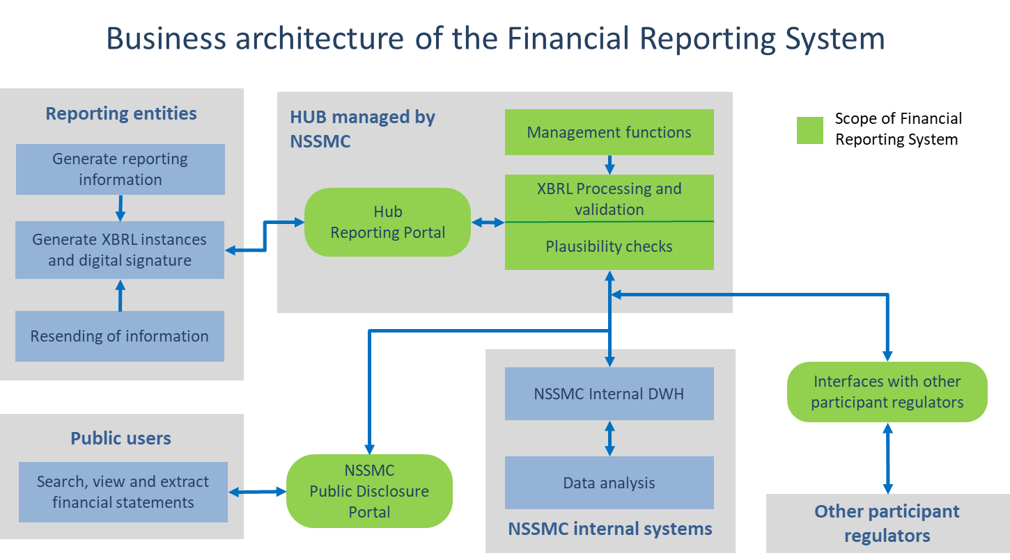

## 

## System Requirements

The Offeror must include in its technical proposal a detailed answer to each of the requirements indicated in this section, following the template included in the following pages.

For Functional, Non-functional and Maintenance and Support Services Requirements, each of the requirements is characterized by two columns:

* The first column labelled as “P/F” (pass or fail), indicates if the requirements or group of requirements are considered as obligatory. When a requirement or group of requirements is marked with “yes”, it means that any proposal not fulfilling this requirement can be excluded from the evaluation.
* The second column labelled as “P”, indicates the priority level of the requirement or group of requirements in the evaluation. Priority levels are assigned from 1 to 3, where 3 means high priority, 2 medium priority and 1 low priority.

The Offeror should complete this template fulfilling two additional columns:

* The columns labelled as “RC”, indicates the response code of the tenderer to the requirement. The Offeror should include one of the following response codes:

|  |  |
| --- | --- |
| **Code** | **Description** |
| A+ | The proposed solution fulfils the requirement as a standard functionality and provides additional features to the functionalities specified in the requirement |
| A | The proposed solution fulfils the requirement as a standard functionality with no changes required |
| B | The requirement can be fulfilled by using provided configuration tools in the system, to be performed by the operational users or members of the IT department of the NSSMC, without the need for significant training |
| C | The requirement can be fulfilled by using configuration tools in the system, to be performed by the supplier |
| D | The requirement will be delivered as a bespoke development |
| E | The requirement cannot be fulfilled |

In the column labelled as “Description”, the Offeror should indicate (maximum 200 words) the way in which the requirement is fulfilled. The column may also reference the section in the proposal in which the item is fully described. Failure to provide a descriptive response will mean that your response will score less than if one is provided.

The quality of the response will be evaluated by the Committee according to the following categories:

|  |  |
| --- | --- |
| **Code** | **Description** |
| A | The response provided gives full confidence of the tenderer’s ability to deliver the requirement |
| B | The response provided gives considerable confidence of the tenderer’s ability to deliver the requirement |
| C | The response provided gives some confidence of the tenderer’s ability to deliver the requirement |
| D | The response provided gives little confidence of the tenderer’s ability to deliver the requirement |
| E | The response provided gives no confidence of the tenderer’s ability to deliver the requirement |

For Technical and Implementation Requirements, the evaluation will be based on the quality of the response. ALL of the above has to come later, after the business context and closer to the forms. This is confusing. This is more like instructions to fill out the forms.

**Form A.3.1. Functional requirements**

| **Code**  **FR** | **Requirement** | **P/F** | **P** | **RC** | **Description** |
| --- | --- | --- | --- | --- | --- |
| **1.** | **Management Functions** | | | | |
| **1.1** | **Manage reporting entities** | | | |  |
| 1.1.1 | Provide the NSSMC with the ability to register and maintain relevant data of reporting entities including identification data, contact details, type of entity, reporting profile, relevant regulators and other information as defined by the NSSMC. | Yes | 3 |  |  |
| 1.1.2 | Registered reporting entities will be enabled to have access to the System. Internal and Participant Regulator users will have the ability to enable reporting entities to use the System. |  | 2 |  |  |
| 1.1.3 | Reporting entities that operate within a single reporting group to be provided with a shared point of access. |  | 1 |  |  |
| 1.1.4 | Provide the NSSMC with the ability to retrieve, view and edit reporting entity profile information. |  | 2 |  |  |
| 1.1.5 | Provide the NSSMC with the ability to support the maintenance of reporting entity / group contact details. |  | 2 |  |  |
| 1.1.6 | Provide Internal Users with the ability to record the individual Directives and Ukrainian laws which are relevant to the Reporting Entity. |  | 1 |  |  |
| 1.1.7 | Provide Internal Users and Participant Regulators with the ability to define and manage new profile information against a Reporting Entity. |  | 2 |  |  |
| **1.2** | **Manage internal users** | | | |  |
| 1.2.1 | Provide NSSMC with the ability to create and manage Internal User accounts with roles, permissions and access rights for designated users at the NSSMC, acting as hub operator. | Yes | 3 |  |  |
| 1.2.2 | Provide NSSMC with the ability to re-assign Internal User roles, subject to business rules. |  | 2 |  |  |
| 1.2.3 | The System will manage Internal User authentication based on secure Identity Access Management procedures adopted by the NSSMC | Yes | 3 |  |  |
| 1.2.4 | Provide Internal Users with the ability to configure System permissions by system role for both Internal, Participant Regulator and Reporting Entity Users.  e.g. permissions to access and use data and functionality may be based on the classification of data, by department, by team etc. For non-internal Users roles, the NSSMC may set up standard users to not see other user details, but allow other specially authorised users to view all users within their Reporting Entity. |  | 2 |  |  |
| 1.2.5 | Provide Internal Users with the ability to manually enable and disable Internal User and External (Participant Regulators or Reporting Entities) User Accounts.  e.g. the NSSMC may want to disable any users who have not accessed the system in 6 months. |  | 2 |  |  |
| 1.2.6 | Provide Internal Users with the ability to monitor the number of External Users set up per Participant Regulator or Reporting Entity.  e.g. view how many users a Participant Regulator or a Reporting Entity have set up in order to cap them off System if a defined limit is reached. |  | 1 |  |  |
| 1.2.7 | Provide Internal Users with the ability to Manage their security credentials.  e.g. change password. |  | 2 |  |  |
| **1.3** | **Manage participant regulators users** | | | |  |
| 1.3.1 | Provide NSSMC, as the hub operator, with the ability to create and manage user accounts with roles, permissions and access rights for designated users at the Participant Regulators.  Note: NSSMC is Participant Regulator as well. For NSSMC users, the FRS is the backbone of its internal systems. For other Participant Regulators users, the FRS is only its “single window collection application”. | Yes | 3 |  |  |
| 1.3.2 | Provide NSSMC with the ability to re-assign Participant Regulators user roles, subject to business rules. |  | 2 |  |  |
| 1.3.3 | The System will manage user authentication based on secure Identity Access Management procedures adopted by the NSSMC (based on digital certificates, to be defined based on nationally adopted standards). | Yes | 3 |  |  |
| 1.3.4 | Provide Participant Regulators Users with the ability to Manage their security credentials.  e.g. change password. |  | 2 |  |  |
| **1.4** | **Manage reporting entities users** | | | |  |
| 1.4.1 | Provide the NSSMC with the ability to create and manage external user accounts for designated users at the reporting entities with roles, permissions and access rights.   * Provide Internal Users with the ability to Maintain a Reporting Entity’s key main contact details * Provide Reporting Entities Users with the ability to Maintain the rest of their contact details | Yes | 3 |  |  |
| 1.4.2 | Provide the NSSMC with the ability to re-assign external user roles, subject to business rules. |  | 2 |  |  |
| 1.4.3 | Provide Internal Users with the ability to Define and Manage a Reporting Group.  e.g. to support user management requirements such as allowing a single Reporting Entity User to perform actions in the System for multiple Reporting Entities from the same group, without having to log in multiple times. |  | 2 |  |  |
| 1.4.4 | The System will manage external user authentication based on secure Identity Access Management procedures adopted by the NSSMC (based on digital certificates, ) distinguishing preparers and auditors. | Yes | 3 |  |  |
| 1.4.5 | Provide Reporting Entities Users with the ability to Manage their security credentials.  e.g. change password. |  | 2 |  |  |
| **1.5** | **Manage XBRL Taxonomies** | | | |  |
| 1.5.1 | Provide the NSSMC with the ability to manage different XBRL taxonomies, as defined by Ministry of Finance of Ukraine and extended (if applicable) by the NSSMC. | Yes | 3 |  |  |
| 1.5.2 | The NSSMC will have the ability to add, maintain and manage versions of all relevant data submission templates and taxonomies within the System, including related rules and meta data, such as applicable date ranges, reporting timetable etc. |  | 2 |  |  |
| 1.5.3 | Commitment to provide NSSMC with the ability to Manage versions of the XBRL Taxonomy and other Reporting Templates, to be published by ESMA in their ITSs. |  | 1 |  |  |
| 1.5.4 | Provide Internal Users with the ability to manage versions of Structured and Unstructured Reporting Templates defined by NSSMC. |  | 2 |  |  |
| **1.6** | **Manage reporting profiles and schedules** | | | |  |
| 1.6.1 | Provide the NSSMC with the ability to define and manage different reporting profiles to be assigned to each reporting entity. The reporting profile will be associated to one or several reporting requirements to be fulfilled by the reporting entities in the profile. | Yes | 3 |  |  |
| 1.6.2 | Provide the NSSMC with the ability to define and manage different types of reporting requirements, indicating the reporting taxonomy to be submitted, receiver regulator or regulators (regulator or regulators to whom the reporting information is to be distributed), the schedule of submission (frequencies and due dates) and the preparers and auditor’s digital signatures required confirming the submitted financial data. |  | 2 |  |  |
| 1.6.3 | Provide the NSSMC with the ability to define and maintain the schedule of submission for each type of reporting requirement, including reporting type, frequency, period in which submission is open for collection and due date. |  | 3 |  |  |
| 1.6.4 | Provide Participant Regulator users with the ability to request changes to a Reporting Entity's Schedule of returns.  e.g. request an additional reporting requirement due to a significant event |  | 1 |  |  |
| 1.6.5 | For each Reporting Template on a Schedule, the System shall automatically determine the submission deadline based on the Reporting Entity's profile data.  e.g. Annual Reporting required a specific number of weeks after financial year end date |  | 2 |  |  |
| 1.6.6 | Provide Internal Users with the ability to capture the extension date and the reason for the extension, if provided. |  | 2 |  |  |
| 1.6.7 | Provide the reporting entities with the ability to view their reporting requirements and schedules. |  | 3 |  |  |
| 1.6.8 | Provide the NSSMC and the Participant Regulators with the ability to monitor the fulfilment of reporting requirements by the reporting entities and establish alerts to Regulators based on the monitoring activity. |  | 3 |  |  |
| 1.6.9 | Provide the NSSMC with the ability to generate automatic alerts and notifications to the reporting entities when reporting requirements schedules are overdue. |  | 2 |  |  |
| **2.** | **Exchange and process management** | | | | |
| **2.1** | **Message authentication** | | | |  |
| 2.1.1 | All messages sent by external users will be authenticated based on secure Identity Access Management procedures adopted by the NSSMC (based on digital certificates). | Yes | 3 |  |  |
| **2.2** | **Submission of XBRL or Inline XBRL instance documents** | | | |  |
| 2.2.1 | Sending instance documents to the hub will be achieved in two ways, either via a supply service ("system-to-system"), or via a document upload portal.  The NSSMC will be able to support those Reporting Entities who wish to integrate their back-office systems with the FRS solution, in order to be able to process submissions directly without needing to manually access a web based user interface. | Yes | 3 |  |  |
| 2.2.2 | Provide the NSSMC with the ability to define and configure the exchange rules for the XBRL or Inline XBRL instance documents to be submitted by the Reporting Entities. The exchange rules shall include options such as:   * Allowing or rejecting the submission of instance documents out of the reporting schedule. * Define the time frame in which a submission can be cancelled by the sender. * Temporally suspend the reception of instance documents. |  | 2 |  |  |
| 2.2.3 | Provide authorised users at the Reporting Entities with the ability to submit instance documents to the Financial Reporting System, following the exchange rules defined by the NSSMC. The user shall specify the reporting requirement and period corresponding to the instance document. | Yes | 3 |  |  |
| 2.2.4 | Provide authorised users of the Reporting Entities with the ability to cancel a previously submitted instance document within the time frame defined by the NSSMC. |  | 1 |  |  |
| 2.2.5 | Provide authorised users of the Reporting Entities with the ability to resubmit previously reported data at any point, for any historic period.  e.g. to correct data |  | 2 |  |  |
| 2.2.6 | The System shall have the ability to capture the date of submission / resubmission |  | 2 |  |  |
| 2.2.7 | The resubmission shall specify the reporting requirement and period to be corrected and the reasons for modification. |  | 2 |  |  |
| 2.2.8 | Provide Reporting Entities Users with the ability to specify a reason for Resubmission. The reason for Resubmission can be a predefined list and/or free format.  e.g. incorrect data previously submitted |  | 2 |  |  |
| 2.2.9 | The NSSMC shall have the ability to optionally review the resubmissions and approve or reject the new submission, manually or subject to business rules. In case of not being put on hold or rejected, the new instance document will be validated and it will substitute the previously reported data. The new reported data will be flagged as resubmission and the previously submitted instance document will be stored and accessible in the System. |  | 2 |  |  |
| 2.2.10 | Provide authorised users of the Reporting Entities with the ability to consult the list and status of submitted instance documents for a period of time. |  | 2 |  |  |
| 2.2.11 | Provide internal and external users with the ability to exchange information messages with structured or unstructured attached files |  | 1 |  |  |
| 2.2.12 | The System shall have the ability to receive data submissions in other electronic based formats  e.g. XML, CSV, WORD, EXCEL, POWERPOINT, PDF, JPG, PNG etc. |  | 2 |  |  |
| 2.2.13 | The System shall have the ability to receive from Reporting Entities unstructured data for document storage  e.g. Regulatory Reports |  | 1 |  |  |
| 2.2.14 | Provide Reporting Entities Users with the ability to upload files individually |  | 2 |  |  |
| 2.2.15 | Provide Reporting Entities Users with the ability to cancel the upload of a file or multiple files after it has commenced |  | 1 |  |  |
| 2.2.16 | Provide Internal Users with the ability to store and view any valid return submitted by a Reporting Entity (current and previous submissions)  e.g. for use in trend analysis included in Plausibility Rules |  | 2 |  |  |
| 2.2.17 | Provide Reporting Entities Users with the ability to upload multiple files concurrently |  | 1 |  |  |
| 2.2.18 | Provide Reporting Entities Users with a progress indicator when uploading a file(s)  e.g. % progress bar |  | 1 |  |  |
| 2.2.19 | Provide Reporting Entities Users with the ability to associate structured information and / or meta-data to the data being submitted. |  | 2 |  |  |
| 2.2.20 | Provide Reporting Entities Users with the ability to flag that a Reporting Template is "Not Reported" |  | 2 |  |  |
| 2.2.21 | Provide Internal and Participant Regulator Users with the ability to view any valid return submitted by a Reporting Entity (current and previous submissions) and to upload work documents to be stored alongside the filed data.  e.g for other staff to see what was analysed or reported by other peers. |  | 2 |  |  |
| **2.3** | **Process and validate submissions** | | | |  |
| 2.3.1 | The System shall automatically perform the validation of the submissions, based on the type of reporting requirement associated to the submission. In particular, the system will perform the following checks:   * The signature of the sender and the auditor are authenticated. * The sender is a Reporting Entity user authorised to perform the submission. * The submission corresponds to a reporting requirement and period open for submission for the reporting entity. * The submission includes the signatures required for the type of reporting requirement, confirming the financial data and auditor report included in the instance document. * The submission includes an instance document corresponding to the taxonomy version specified for the reporting requirement. * The auditor report corresponds to the financial statements being submitted | Yes | 3 |  |  |
| 2.3.2 | The System will notify the reporting entity with the result of the submission validation and, in case of rejection, will indicate the reasons for rejection in a business user friendly manner. |  | 2 |  |  |
| 2.3.3 | The System shall automatically determine how to process incoming data based on a set of predefined criteria and rules.  i.e. "process" means how and where to store, and where to route the data within the System. E.g. send for validation  Criteria and rules may be based on file format, metadata, Reporting Entity profile data etc. |  | 2 |  |  |
| 2.3.4 | The System shall receive and store all valid data submitted  e.g. if a Reporting Entity submits a valid submission of data, and then at a later point in the same reporting period a Resubmission which is also valid, then both submissions should be stored | Yes | 3 |  |  |
| 2.3.5 | The System shall restrict Internal Users from amending data within the System received from Third Party Data Sources.  e.g. data from Reporting Entities, Third Party Data Sources  Note: It should be possible for Internal Users to amend manually inputted data such as data appended to data |  | 2 |  |  |
| 2.3.6 | The System shall prioritize processing of returns from certain Reporting Entities over others based on configurable criteria or rules  e.g. by category, by type of Reporting Entity |  | 1 |  |  |
| 2.3.7 | The System shall automatically route files destined for document storage (i.e. rather than analytics) to the correct folder  e.g. documents received from a specific Reporting Entity go to that specific Reporting Entity file site folder and/or to specific Internal and Participant Regulators users, who will have the ability to re-route these documents to other peers. |  | 1 |  |  |
| 2.3.8 | The System shall store Invalid Data received, until it can be automatically replaced by a valid set of data, either via a Resubmission or a re-running of Validation Rules by Internal Users  e.g. the data does not need to pass validation to be stored, to allow the Internal Users access to the data in exceptional circumstances. In addition, experience would suggest that some Validation Rules will be incorrect and require correction by an Internal User. Upon re-running corrected rules, it should be possible to re-validate data without a re-submission. |  | 1 |  |  |
| 2.3.9 | The System shall automatically determine the data security classification of a file upon a predefined business rule  e.g. on Unstructured file submissions a default sensitivity of NSSMC confidential private could be assigned to all documents of a certain type likely to contain market sensitive data (using meta data) with default access provided to selected internal users |  | 2 |  |  |
| 2.3.10 | Provide NSSMC (both as Internal or as Participant Regulator) Users with the ability to Define and Configure the System rules which determine where to store, access files, name and how to classify them  e.g. if the business changes their file structure they would want to update the rules to reflect this |  | 2 |  |  |
| 2.3.11 | The System shall automatically track a submission status through various stages of the process  e.g. submitted, validated, plausibility checked, exported. This will help NSSMC know how far data has been processed in case a Reporting Entity resubmits data |  | 1 |  |  |
| 2.3.12 | Provide Internal Users with the ability to append additional data to a data item and view what has been added.  e.g. Plausibility investigation |  | 1 |  |  |
| **2.4** | **Manage and check plausibility rules** | | | |  |
| 2.4.1 | Provide the NSSMC with the ability to define and configure plausibility rules (in addition to the validation rules defined in the taxonomy) for the data defined by the NSSMC. The plausibility rules and the way in which they are applied will be defined by the NSSMC in agreement with the Participant Regulators, for those reporting requirements in which other regulators are defined as receivers of the information.  Plausibility checks may include checks if a data element is unusually large or small, checks which compare a data set against a predefined range of values, etc. |  | 3 |  |  |
| 2.4.2 | The NSSMC will be able to retrieve and use data from third party sources within the System to support processing activity (such as Plausibility checking).  Data might be available through manual upload, batch upload or integration. Examples of data types include exchange rates, reference data lists and market data. |  | 2 |  |  |
| 2.4.3 | Provide Internal Users with the ability to set up and manage groups of Reporting Entities to support Plausibility Rules  e.g. the ability to set up peer groups to run sector/peer group specific plausibility checks or checks which have sector/peer group specific variables |  | 2 |  |  |
| 2.4.4 | Provide the NSSMC with the ability to individually switch on and off plausibility rules., for all or specific Reporting Entities, or all rules for all or specific Reporting Entities |  | 2 |  |  |
| 2.4.5 | Provide the NSSMC with the ability to define which plausibility rules should be triggered automatically and which manually. |  | 2 |  |  |
| 2.4.6 | Provide the NSSMC with the ability to manually or automatically run plausibility checks against submitted data. |  | 2 |  |  |
| 2.4.7 | Provide Internal Users and relevant Participant Regulators with the ability to view the Plausibility Outcome  e.g. red, amber, green outcome |  | 2 |  |  |
| 2.4.8 | Provide the NSSMC with the ability to define and configure alerts and notifications based on the result of applying the plausibility rules. |  | 1 |  |  |
| **2.5** | **Validation of instance documents** | | | |  |
| 2.5.1 | Provide the NSSMC with the ability to define and configure different standardized procedures for validating instance documents, based on the profile of the reporting entity and the type of reporting requirement. | Yes | 3 |  |  |
| 2.5.2 | The NSSMC will be able to configure internally defined validation rules. |  | 2 |  |  |
| 2.5.3 | In addition, the NSSMC will be able to version control all validation rules, with the ability to select which rules to apply.  e.g. to switch individual validation rules on and off at a rule level, on a per Reporting Entity basis.  i.e. specific rules, for specific Reporting Entities |  | 2 |  |  |
| 2.5.4 | The NSSMC will be able to test changes to validation prior to applying them in live. |  | 1 |  |  |
| 2.5.5 | The System shall automatically be able to determine which Validation Rules should apply to a Resubmission of data.  e.g. a previous set of Validation Rules may need to be applied to resubmitted data, and the current Validation Rules applied to new submissions only |  | 2 |  |  |
| 2.5.6 | The configuration should allow to define if instance documents shall be automatically validated upon reception or if they shall be temporally stored, prior to validation. The configuration should also allow to define if validation of temporally stored instance documents shall be launched manually or automatically, based on parameters such as volume of stored documents, predefined time frames, etc. |  | 2 |  |  |
| 2.5.7 | Based on the validation procedure associated to the submission, the System will automatically perform the validation of the XBRL or Inline XBRL instance document, based on the validation rules specified in each taxonomy. |  | 2 |  |  |
| 2.5.8 | The XBRL version used on the system taxonomies is the following: XBRL 2.1 Specification dated 2003-12-31 (Recommendation) with errata from 2013-02-20, Dimensions 1.0 Specification dated 2006-09-18 (Recommendation) with errata from 2012-01-25, Inline XBRL 1.1 Specification dated 2013-11-18 (Recommendation) and Generic Links 1.0 (Recommendation) dated 2009-06-22 (issued as part of the Formula 1.0 specification). | Yes | 3 |  |  |
| 2.5.9 | The System shall inform the Reporting Entities on the status and result of the validation process. In case of non-validation, the System will send to the reporting entity a notification message indicating the reasons of rejection in a business user friendly manner. |  |  |  |  |
| 2.5.10 | The System shall allow straight-through processing (STP) procedure in case of error-free instance documents.  The System shall automatically pass data directly through to analytics unless it has a Validation Outcome of "failed" or specific Plausibility Outcome  e.g. data has passed validation and data has met the predefined level of Plausibility (e.g. only low impact Plausibility Rule with an outcome of amber have been raised therefore allow the submission data to pass through) |  | 1 |  |  |
| 2.5.11 | Provide Internal Users with the ability to manually push data directly through to analytics, in exceptional cases  e.g. even if the predefined quality criteria have not been met. |  | 1 |  |  |
| **2.6** | **Monitoring of submissions** | | | |  |
| 2.6.1 | Provide the NSSMC and the participant regulators with the ability to monitor with a dashboard the status of the present and previous submissions by the Reporting Entities. The dashboard will provide on-line information to each participant regulator regarding:   * Number of submissions sent, validated and rejected. * Number of instance documents submitted, validated and rejected. * Level of fulfilment of each reporting requirement and period, indicating the instance documents, validated, rejected, and overdue.   The dashboard will allow to define the period of reporting and disaggregate the information based on several criteria such as reporting profile, reporting entity, type of reporting requirement, receiver regulator, period, type of rejection, etc. | Yes | 3 |  |  |
| 2.6.2 | Provide the NSSMC and participant regulators with the ability to search, filter, select, view and print data submitted by the Reporting Entities in a readable format. |  | 2 |  |  |
| 2.6.3 | Provide Internal Users with the ability to identify the most recent version of the same data item from multiple submissions by a Reporting Entity |  | 2 |  |  |
| 2.6.4 | Provide Internal Users with the ability to drill down on data to its lowest level of granularity  e.g. to see all components of the validation or plausibility rule |  | 2 |  |  |
| **3.** | **Staging database** | | | | |
| **3.1** | **Extract and storage of data** | | | |  |
| 3.1.1 | The System shall automatically extract and storage the financial data from instance documents, once validation is completed. For this purpose, the System will include a relational database, for the purposes of staging data extracted from the instance documents. | Yes | 3 |  |  |
| 3.1.2 | The staging database will maintain historical series of reported data, supporting the calculation of aggregates, totals, trends and other parameter-based mathematical operations. |  | 2 |  |  |
| 3.1.3 | Provide the NSSMC with the ability to define standardized analytical reports based on historical data, to be accessed by internal and external users. |  | 1 |  |  |
| 3.1.4 | The System shall store the validated XBRL or Inline XBRL instance documents allowing to be accessed by Internal and Participant Regulator users. |  | 2 |  |  |
| **4.** | **Manage and send notifications** |  |  |  |  |
| **4.1** | **Manage and send notifications** |  |  |  |  |
| 4.1.1 | Provide NSSMC with the ability to configure and issue standardized and customized notifications based on a number of triggers across the data management lifecycle. | Yes | 3 |  |  |
| 4.1.2 | Provide NSSMC with the ability to define notifications with:   * Fixed content * Combination of fixed and variable content   + Manually populated   + Auto-populated |  | 2 |  |  |
| 4.1.3 | Provide NSSMC with the ability to review, amend, suppress, and/or release notifications to Internal, Participant Regulators and Reporting Entities Users.  e.g. Reporting Entities will receive notifications upon different events related to submission and checking of data. |  | 1 |  |  |
| 4.1.4 | When notifications are sent to external users, appropriate security should be maintained e.g. sensitive information should not be sent via email and instead the user should be requested to login to the system to view the sensitive information. |  | 2 |  |  |
| 4.1.5 | The System shall automatically issue Notifications to inform Internal Users when user action is required within the System. |  | 2 |  |  |
| 4.1.6 | Provide Participant Regulator Users with the ability to respond to a validation and/or plausibility notification and for The System to store the information and retain an audit trail of the communication. |  | 2 |  |  |
| 4.1.7 | The System shall automatically issue Notifications when user action is required. |  | 2 |  |  |
| 4.1.8 | The System shall automatically release a Notification after a predefined period of time based on rules. |  | 2 |  |  |
| 4.1.9 | The System shall automatically issue Notifications based on system triggers. |  | 2 |  |  |
| 4.1.10 | Provide Internal Users with the ability to switch Notifications on and off by type and/or by Reporting Entity in advance of being triggered.  e.g. to exclude Reporting Entities from receiving specific or all Notifications types, or to turn a Notification off for all Reporting Entities. |  | 1 |  |  |
| 4.1.11 | Provide Reporting Entities Users with the ability to associate a file with a response to a validation and/or Plausibility Notification and for The System to store the information.  e.g. the external user responds to a Plausibility query with an explanatory message as well as an attached spreadsheet. This is to ensure the spreadsheet is retained alongside the message. |  | 1 |  |  |
| 4.1.12 | The System shall automatically record the reason against a Plausibility Outcome using the latest response provided by an External User.  i.e. without the internal user having to manually cut and paste response information from the External User into the System. |  | 1 |  |  |
| 4.1.13 | Provide External Users with the ability to query the status of a submission and receive status / event Notifications. |  | 2 |  |  |
| **5.** | **Interfaces with participant regulators** | | | | |
| **5.1** | **Interfaces with participant regulators** | | | |  |
| 5.1.1 | Participant Regulators will automatically receive the validated XBRL financial statements corresponding to the reporting requirements in which the participant regulator is defined as receiver. | Yes | 3 |  |  |
| 5.1.2 | The information corresponding to the scope of activity of each regulator will not be possible to be accessed by other regulators. | Yes | 3 |  |  |
| 5.1.3 | Provide the NSSMC, as the hub operator, with the ability to configure the parameters for extracting information to Participant Regulators. |  | 2 |  |  |
| 5.1.4 | The NSSMC will be able to prepare, extract and transfer data to Participant Regulators. Preparing the data will include capabilities such as defining, reviewing and filtering the data set. |  | 2 |  |  |
| 5.1.5 | The data could be all the raw data received from Reporting Entities (standard way to share data with Participant Regulators), or a subset thereof, on an exception basis. |  | 1 |  |  |
| 5.1.6 | Extracting the data will include capabilities to do so automatically or manually into various formats. |  | 1 |  |  |
| 5.1.7 | Transferring the data will include automatically and/or manually sending data to Participant Regulators. |  | 1 |  |  |
| 5.1.8 | Provide Internal Users with the ability to share with Participant Regulators raw data or a unique representation of it in a RDBMS.  e.g. all Reporting Templates, specifically data within the XBRL Taxonomy in XBRL or Inline XBRL format. |  | 2 |  |  |
| **6.** | **Relationship with NSSMC internal systems**  The NSSMC will have two roles in the FRS:   * Internal: The NSSMC will manage the FRS, as the hub operator * External: The NSSMC will be as well a Participant Regulator in the FRS, supporting on it part of its business architecture, as the securities and other financial markets regulator in Ukraine. | | | | |
| **6.1** | **Role as Hub operator** | | | |  |
| 6.1.1 | Provide the NSSMC with the ability to automatically extract the reporting data stored in the staging area to the business intelligence or data warehouse of the NSSMC. | Yes | 3 |  |  |
| 6.1.2 | Provide the NSSMC with the ability to configure the parameters for extracting information to the internal data warehouse. |  | 2 |  |  |
| 6.1.3 | Provide Internal Users with the ability to use Structured data for analytical purposes, subject to the data being received in a standard based format  e.g. agreed format may be Excel, XBRL, Inline XBRL and CSV etc. |  | 2 |  |  |
| 6.1.4 | The System shall have the ability to interface with external applications such as reference data sources, workflow and document management systems, etc. (including but not limited to read / write capability)  e.g. master data sources, etc. |  | 1 |  |  |
| **6.2** | **Role as Participant Regulator**  The NSSMC has specific requirements, not mandatory for the FRS hub, but needed to be addressed, in the context of a standard Securities and Exchange Commission business architecture typical to a Capital Markets regulator. | | | |  |
| 6.2.1 | XBRL enabled European frameworks: application vendor commitment to support XBRL enabled European frameworks which will be applicable for the NSSMC in the future:   * ESMA specific requirements for the Listed Companies within the Public Interest Entities (PIEs). * Either EBA or EIOPA, future regulatory frameworks for other financial intermediaries or for investment or pension plan managers. |  | 2 |  |  |
| 6.2.2 | NSSMC business requirements, as a Capital Markets regulator:   * Reporting Collection and Validation (covered by the FRS) * Workflow management   + Licensing,   + Register   + Reporting (covered by the FRS)   + Enforcement * Market surveillance   + Market Monitoring   + Alerts Management * Data Analysis   + DWH and analytics on the valid financial statements, notes and audit reports * Disclosure (covered by the FRS) |  | 2 |  |  |
| **7.** | **Information disclosure** | | | | |
| **7.1** | **Public access to reporting information** | | | |  |
| 7.1.1 | Provide public users the ability to search, select and view instance documents of Reporting Entities in a readable format or download instance documents in XBRL or Inline XBRL format. Searching criteria shall include reporting profile, identifier, name of reporting entity, reporting requirement and reporting period. | Yes | 3 |  |  |
| 7.1.2 | Provide the NSSMC with the ability to automatically associate a disclosure flag (open, restricted) to instance documents based on the status and result of the validation. |  | 2 |  |  |
| 7.1.3 | The NSSMC shall also be allowed to manually select and associate a disclosure flag (open, restricted) to a particular set of instance documents, based on criteria such as reporting profile, reporting entity, reporting requirements, period, etc. |  | 2 |  |  |
| 7.1.4 | Public users shall be authorised to access only those instance documents flagged as open. |  | 3 |  |  |
| 7.1.5 | Reporting information disclosed will be a consistent, human-readable image of the structured data received in XBRL or Inline XBRL format.  Consistent means there must be certainty all stakeholders are looking at the same information which was filed by the Reporting Entity |  | 3 |  |  |
| **7.2** | **Share data with third parties** | | | |  |
| 7.2.1 | Provide the NSSMC with the ability to prepare, extract and transfer data to third parties, including the capabilities for defining, reviewing and filtering the data set. | Yes | 3 |  |  |
| 7.2.2 | Provide Internal Users with the ability to configure data sets to be automatically shared with third parties. |  | 2 |  |  |
| 7.2.3 | The System shall automatically send data to a third parties subject to the configuration defined by the NSSMC. |  | 2 |  |  |
| 7.2.4 | Provide Internal Users with the ability to manually extract data required to send to Third Parties. |  | 2 |  |  |
| 7.2.5 | Provide Internal Users with the ability to extract data from the System in Standards Based Formats.  e.g. Excel, CSV, XML, Inline XBRL, XBRL for EIOPA and/or EBA or ECB etc. |  | 2 |  |  |
| 7.2.6 | Provide Internal Users with the ability to manually stop data being automatically sent to a Third Party  e.g. a user may wish to pull out a particular Reporting Entity's data being sent to a third party |  | 2 |  |  |
| 7.2.7 | Provide Internal Users with the ability to manually send data to a Third Party |  | 2 |  |  |
| 7.2.8 | Provide Internal Users with the ability to review data prior to sending data to Third Parties |  | 1 |  |  |
| **8.** | **Operational reporting** | | | | |
| **8.1** | **Operational reporting** | | | |  |
| 8.1.1 | The NSSMC will be able to generate reports which detail activity being undertaken and the status of information being processed throughout the System.  e.g. distinguishing valid from invalid data, per status of submission, at any time, audit data, status of Reporting Entities, etc | Yes | 3 |  |  |
| 8.1.2 | Areas of interest for operational reporting will include:  e.g. system usage, status and metrics on data submissions, resubmissions, information on schedules, validation and plausibility activity and data sent to Participant Regulators and/or third parties.  Some reporting may be achieved through extracts of data from the system or report generation, while some information may be displayed on screen for users to be able to view  It must be possible to collect and view performance data of the system as data is processed. (upload to external interface, transfer from external interface to data repository, time to process validation and plausibility rules, etc.) |  | 2 |  |  |
| **9.** | **Help and user support services** | | | |  |
| **9.1** | **Help and user support services** | | | |  |
| 9.1.1 | Provide the internal and external users with offline guidance to support effective use of the FRS  e.g. user guides, web learning, etc. | Yes | 3 |  |  |
| 9.1.2 | Provide the internal and external users with on screen user help services |  | 2 |  |  |
| 9.1.3 | Provide the NSSMC with the ability to emulate a reporting entity's view of the System to help the provision of user and technical support to Reporting Entities. |  | 2 |  |  |

**Form A.3.2. Non-functional requirements**

| **Code**  **NFR** | **Requirement** | **P/F** | **P** | **RC** | **Description** |
| --- | --- | --- | --- | --- | --- |
| **1.** | **Data** | | | |  |
| 1.1 | **Accuracy**  Any notifications, data requests and collected data are accurately presented to appropriate System users (whether Reporting Entity, Participant Regulator or Internal user). |  | 2 |  |  |
| 1.2 | **Archiving**  The System must provide Internal users with the ability to define archive and retrieval data policies for different Reporting Template(s) and types of return  E.g. Archive all quarterly data, all Reporting Templates where there is not a fixed number of lines (e.g. asset data) after 7 years. Archive all annual Reporting Templates where there is a fixed number of lines (e.g. balance sheet, etc) after 25 years |  | 2 |  |  |
| 1.3 | **Integrity**  The integrity of collected data must be maintained from the point of receipt by the System of collected data and throughout the processing, handling and use of that collected data. |  | 2 |  |  |
| 1.4 | **Metadata**  Metadata must be associated to a file when uploaded to the System at the time of upload.  Where and how this is stored?  Is it possible to configure what metadata is associated? |  | 2 |  |  |
| 1.5 | **Storage**  The System must be able to store the data in the original format that it has been submitted in |  | 2 |  |  |
| 1.6 | **Retrieval**  Internal users must be able to retrieve archived data when required e.g. raw data files, along with relevant versions of the taxonomies and supporting documentation |  | 2 |  |  |
| 1.7 | **Data sharing**  Data sent automatically to Participant Regulators shall be sent daily to spread the load. |  | 2 |  |  |
| **2.** | **Development and maintenance** | | | |  |
| 2.1 | **Changeability**  Any changes to the System must be able to be packaged and deployed incrementally and automatically. |  | 2 |  |  |
| 2.2 | **Development**  Supported and documented read-only access to the underlying data model of the System must be available to enable NSSMC to create its own reports or use the data in other systems. |  | 2 |  |  |
| 2.3 | **Environments** |  |  |  |  |
| 2.3.1 | NSSMC will need differentiated environments to support:   * Production,   + go live environment * Pre-Production * User Acceptance Testing * System Integration Testing,   + main system test environment * Development * Training   Users must be given different login credentials to login to different environments. |  | 2 |  |  |
| 2.3.2 | To support “system to system/B2B” integration”, the System should be supported by two types of externally facing test environments used by software vendors / 3rd parties to test against:   * A version of the current production system * A version which contains any new changes to the system |  | 2 |  |  |
| 2.3.3 | External facing test environments must be clearly distinguishable so the user knows which version they are accessing. |  | 2 |  |  |
| 2.3.4 | Users must be given different login credentials to login to different environments. |  | 2 |  |  |
| 2.4 | **Extensibility**  The System must be extendable for new and existing features without having to rebuild the entire solution. |  | 2 |  |  |
| 2.5 | **Testability**  The System must be easily testable using automated testing tools and regression testing.   * Is automated testing is built into your development and maintenance process? * Do you use any automated testing tools for new features and regression testing? * Will these tools be provided to the NSSMC? * Do you use any test management tools? * How do you carry out regression testing? * What regression test artefacts do you intend to produce as part of the project and whether these will be made available for the NSSMC (post-implementation)? |  | 2 |  |  |
| **3.** | **Disaster recovery**  There are no FRS specific back-up and recovery requirements, different from those needed for the whole NSSMC as a capital markets regulator (detailed requirements in accordance with standard NSSMC policy) | | | |  |
| 3.1 | **Solution Recovery**  If there is suspected data corruption in the event of a cyber-attack or other major event, it must be possible to recover to a point of the business’ choosing where the data is known to be accurate. |  | 2 |  |  |
| 3.2 | **Testing**  The solution must be Disaster Recovery tested in accordance with standard NSSMC policy. |  | 2 |  |  |
| **4.** | **Efficiency** | | | |  |
| 4.1 | **Performance Data**  It must be possible to collect and view performance data of the System as data is processed.  For example, the following areas should be measurable:   * upload to external interface * transfer from external interface to data repository * time to process validation and plausibility rules |  | 2 |  |  |
| 4.2 | **Validation response time**  The System will support reports with instance file size up to 30 MB.  The System will support collection, validation, and processing of over (indicate figure based on maximum volume of instances in peak day, initially 9.000) reports within a maximum timeframe of 24 hours. |  | 2 |  |  |
| 4.3 | **Web application response times**  Performance objectives should be in line with the rest of the NSSMC applications.  e.g. average time to load a simple user interface on screen less than 1 second for 90% of page loads, 3 seconds for 90% of page loads for medium / complex screen/ low data intensive pages, 7 seconds for 90% for high data intensive pages, excluding Reporting Entity network and browser performance, etc. |  | 2 |  |  |
| **5.** | **Legal** | | | |  |
| 5.1 | **Cookies**  Persistent and session cookies may be required for using the System. Consent will be requested where required by law |  | 2 |  |  |
| 5.2 | **Regulation**  The solution (rather than content) must adhere to all applicable legislation in all relevant jurisdictions including, but not limited to, the following:   * Copyright, * Data Protection, * Disability, * Accompanying documentation, * Other regulations |  | 2 |  |  |
| **6.** | **Reliability** | | | |  |
| 6.1 | Availability and Service Hours – External  The external facing System must be fully operational 99.9% of the time. |  | 2 |  |  |
| 6.2 | **Availability and Service Hours – Internal**  The internal facing System must be fully operational 98.0% of the time. |  | 2 |  |  |
| 6.3 | **Backups**   * Database backups must be taken at regular intervals. * It must also be possible to choose a point in time to recover back to. * The proposed System will provide or support automated backup / restore functionality * The user will be able to control the frequency and timing of backups |  | 2 |  |  |
| 6.4 | **Recovery**  The solution must be able to integrate data received (via alternative means during a recovery period) while the System is not available. |  | 2 |  |  |
| 6.5 | **Stability**  In the event of a system failure, if the system is mid-processing it shall be able to restart from the last committed transaction. |  | 2 |  |  |
| **7.** | **Security requirements** | | | |  |
| 7.1 | **Access**  The System must use role based access to control what system features and data users are able to use based on the principal of least privilege | Yes | 2 |  |  |
| 7.2 | **Audit logging** |  |  |  |  |
| 7.2.1 | The System shall record an audit log of all system activity  e.g. log in/security authentication records, external user activity, scheduling activity, file upload records, internal user activity, third party data sent, validation activity, plausibility activity, Notification activity, reporting activity, data access activity, data changes, changes to rules activity |  | 2 |  |  |
| 7.2.2 | The audit log must contain as a minimum:   * The user executing the action * The date & time of the event * The action being executed * Security/Login reporting (incl. failed logins) |  | 2 |  |  |
| 7.2.3 | The System shall keep an audit record for every set of data sent to a third party, including but not limited to what data was sent and when.  e.g. see a line by line record of submissions sent, and be able to access the actual contents sent as well. |  | 2 |  |  |
| 7.2.4 | The System shall audit all notifications sent by the System both to Reporting Entities and internally. |  | 2 |  |  |
| 7.2.5 | Provide the NSSMC with the ability to restrict access to all system and user activity audit logs as well as the ability to search, filter and export this data, to certain system roles. |  | 2 |  |  |
| 7.3 | **Authentication** |  |  |  |  |
| 7.3.1 | As per secure Identity Access Management procedures adopted by NSSMC (based on digital certificates)   * External: The System must use recognised industry standard strong authentication. | Yes | 2 |  |  |
| 7.3.2 | As per secure Identity Access Management procedures adopted by NSSMC.   * Internal: Internal users must be able to authenticate using single sign on. | Yes | 2 |  |  |
| 7.4 | **Encryption** |  |  |  |  |
| 7.4.1 | The System must utilise encryption standards as defined / approved by the NSSMC. |  | 2 |  |  |
| 7.4.2 | The solution must ensure that the data is protected as it is transmitted between the Reporting Entities, Participant Regulators and NSSMC. |  | 2 |  |  |
| 7.5 | **Fingerprinting**   * Files must be fingerprinted using an appropriate algorithm as defined / approved by NSSMC IT * Finger printing must happen on upload. * Finger printing should happen on file receipt to check it matches the fingerprint on upload. | Yes | 2 |  |  |
| 7.6 | **Incident monitoring and response** |  |  |  |  |
| 7.6.1 | The System must be monitored for security incidents, collecting logs or audit information on security incidents e.g. breaches of access control policy, static data changes, adding, removing and changing users, activity tracking, tampering with system files etc:   * what information is recorded? * what format is it recorded in? * where it is recorded (e.g. Windows Event Log, proprietary text file, database tables)? * how logs are accessed? |  | 2 |  |  |
| 7.6.2 | Events must be integrated into an incident response process, where all significant incidents are alerted, managed and reported. |  | 2 |  |  |
| 7.7 | **Malware**  Incoming files must be malware checked in the DMZ before being brought into the NSSMC internal network. |  | 2 |  |  |
| 7.8 | **Passwords**   * The System must not transmit passwords over an external network in clear text. * The System must not present passwords unmasked. * The System must not store passwords in clear text and must be stored as a salted hash. * The System must transfer passwords over a secure connection. * The System must enforce strong password formats. | Yes | 2 |  |  |
| 7.9 | **Security questions and answers**  Any set of security questions for Reporting Entities or Participant Regulator user accounts and related answers must follow industry best practices and be approved by the NSSMC. | Yes | 2 |  |  |
| 7.10 | **Session inactivity timeout**  An automatic timeout value for inactivity must be set and be configurable within the System. The value that is set must be approved by the NSSMC.  e.g. 20 minutes | Yes | 2 |  |  |
| 7.11 | **Session termination**  When the window is closed or when they log off, or if the System terminates unexpectedly the session must be terminated. The System should use session based cookies. | Yes | 2 |  |  |
| 7.12 | **User accounts** |  |  |  |  |
| 7.12.1 | Administering internal user accounts for the System will be managed by the NSSMC Identity and Access Management team. |  | 2 |  |  |
| 7.12.2 | Inactive user accounts must be reviewed and locked after 4 months. |  | 2 |  |  |
| 7.13 | **Service and system monitoring** |  |  |  |  |
| 7.13.1 | System must be monitored |  | 2 |  |  |
| 7.13.2 | The System must be capable of identifying how many users are and who is logged on / using the system, their I.P address and time, etc. |  | 2 |  |  |
| **8.** | **Usability** | | | |  |
| 8.1 | **Accessibility**  The System should keep up to best practices and international standards   * e.g. The System must conform to Priority 1 and 2 checkpoints to achieve Level AA compliance as specified in the WCAG2.0 guidelines. * e.g. The System must achieve Level AA compliance. This must be independently tested and certified. * e.g. The System must work with assistive screen readers to support Reporting Entities with users that have visual impairments or who are less able to use websites without the use of assistive technologies. * e.g. The Sysem must support users who may not be able to use a mouse and will need to use the system exclusively via a keyboard. |  | 2 |  |  |
| 8.2 | **Browsers Compatibility** |  |  |  |  |
| 8.2.1 | The facing system must support the following web browser:   * Mozilla Firefox - three latest versions * Google Chrome - three latest versions * Safari version - three latest versions * Microsoft Edge |  | 2 |  |  |
| 8.2.2 | Browser compatibility testing will be carried out on all browsers specified in 8.2.1. |  | 2 |  |  |
| 8.3 | **Calendar**  It must be possible to set bank holidays, non-working days, etc. that can be used by other system functionality. This should be available in each environment. |  | 2 |  |  |
| 8.4 | **Error messages** |  |  |  |  |
| 8.4.1 | The System must display error messages to end users in meaningful and plain Ukrainian or English, as per the user configuration. |  | 2 |  |  |
| 8.4.2 | System error messages must be tagged to distinguish between warnings, information, errors etc. |  | 2 |  |  |
| 8.5 | **Languages**  The System’s user interface must support Ukrainian (UK) and English (EN). |  | 2 |  |  |
| 8.6 | **Learnability** |  |  |  |  |
| 8.6.1 | The System must be consistent in operation, look and feel and vocabulary used throughout all areas of the application. |  | 2 |  |  |
| 8.6.2 | The System should provide an intuitive experience and logical flow through the application. The steps a user must take to complete a task or action, and where they are in that process must be clearly indicated on the user interface of the application. |  | 2 |  |  |
| 8.6.3 | The System's features and functionality should be familiar and predictable. |  | 2 |  |  |
| 8.6.4 | The System should be easy to learn, efficient to use and easy to remember. |  | 2 |  |  |
| 8.7 | **User interfaces**  All System user interfaces must be presented via a web browser. |  | 2 |  |  |
| 8.8 | **Website resolution** |  |  |  |  |
| 8.8.1 | The web user interfaces must support a minimum resolution of 1024 x 768 |  | 2 |  |  |
| 8.8.2 | Other screen resolutions supported |  | 2 |  |  |
| 8.9 | **Web standards** |  |  |  |  |
| 8.9.1 | The System must use XHTML 1.1 or HTML 5. The System must use CSS2.1 or CSS3. |  | 2 |  |  |
| 8.9.2 | The System must pass W3C and CSS validation checks. |  | 2 |  |  |
| 8.10 | **Mobile device compatibility**  The external and internal facing systems should support mobile devices such as tablets. |  | 2 |  |  |
| **9.** | **Usage** | | | |  |
| 9.1 | **Reporting Entities Population**  The System must be able to support a population of up to 30,000 Reporting Entities. |  | 2 |  |  |
| 9.2 | **Monitoring**  The System must provide management information on system statistics, usage trends and data peaks |  | 2 |  |  |
| 9.3 | **User Population – External**   * The System must support a user population of at least **50,000**users from Reporting Entities * The System must support a user population of at least **500**users from Participant Regulators |  | 2 |  |  |
| 9.4 | **User Population Growth – External**  The System must support increasing numbers of external users as other Reporting Entities and users are added over time. |  | 2 |  |  |
| 9.5 | **User Population Peak Usage – External**  The System must maintain good performance, reliability and resilience at points of peak usage, coinciding with the deadlines to submit various returns. |  | 2 |  |  |
| 9.6 | **User Population – Internal**  The System must support a user population of approximately **50** internal users. |  | 2 |  |  |
| 9.7 | **User Population – Peak Usage Internal**  The System must maintain good performance, reliability and resilience at points of peak usage, coinciding with the deadlines to submit various returns. |  | 2 |  |  |

**Form A.3.3. Maintenance and Support Services Requirements**

| **Code**  **MSR** | **Requirement** | **P/F** | **P** | **RC** | **Description** |
| --- | --- | --- | --- | --- | --- |
| **1.** | **Support services** | | | | |
| **1.1** | **Normal service hours** | | | |  |
| 1.1.1 | Normal Service Hours are: 8.00am – 10.00pm (CET+1) UA Working Days  The NSSMC may also have extended Service Hours | Yes | 1 |  |  |
| 1.1.2 | The operational availability of the System during normal Service Hours must be 99.0% |  | 3 |  |  |
| 1.1.3 | The recovery time objective must be at most 6 Hours. | Yes | 2 |  |  |
| 1.1.4 | The recovery point objective of the System must be 0 i.e. no data loss. | Yes | 2 |  |  |
| 1.1.5 | During Disaster Recovery the recovery time objective should be no more than 24 hours. |  | 3 |  |  |
| 1.1.6 | During Disaster Recovery The recovery point objective of the System should be 0 i.e. no data loss.  However, if there is suspected data corruption in the event a cyber-attack or other major event, it must be possible to recover to a point of the business’ choosing where the data is known to be accurate. | Yes | 2 |  |  |
| 1.1.7 | The Contractor will provide support to resolve Incidents and Requests relating to Services they provide that are raised by the NSSMC   * A Service Desk is required and will be open, at a minimum: UA Working Hours (9.00am – 6.00pm from Mon to Thu, 9.00am – 5.00pm before Weekends or Holidays, CET+1, UA Working Days) * However, support must be available at the times required and of requisite quality to support the Service Hours and Availability above specified. Service Desk functions must include resolution to incidents, errors, faults and enquiries etc. as defined in the following Service Requirements. * This may mean the Contractor chooses to provide an “out of Service Desk hours” service – direct to their support agents or consultants for instance. |  | 1 |  |  |
| 1.1.8 | Provide standard Service Desk functionality for NSSMC personnel to communicate (via telephone, email or online) Incidents and Requests to the contractor, manage these and ensure the NSSMC receives responses within the timeframes of the contractor’s standard support package that best suits the NSSMC’s Service Hour and Availability requirements.  The provided service must have Service Levels around how quickly the; Incident or Request is acknowledged; temporary resolutions or Workarounds are provided (if applicable) and permanent resolutions are provided. | Yes | 1 |  |  |
| 1.1.9 | Incidents and Requests to the contractor’s Service Desk will be categorized and prioritized according to the contractor’s standard support package that best suits the NSSMC’s Service Hours and Availability requirements  For example, the NSSMC suggests prioritisation along these lines:   * Priority 1 (Critical) - Critical situation. The System (or a material part of it) is down, unusable or performance is severely degraded. A development project is completely blocked. * Priority 2 (Serious) - Major problem. The System or end users are seriously impacted, or a development project is slowed dramatically. * Priority 3 (Degraded) - A problem that compromises user productivity; functionality is not working as documented, but a workaround exists; serious usability or development issue. * Priority 4 (Minimal) - Minor bugs causing minimal impact to users. Enquiries about product functionality or configuration.   NSSMC shall furnish reasonably sufficient details of the effect of the Incident or Request on NSSMC or other regulator’s business operation and to classify the Incident or Request as Priority 1 – 4 (as categorised above). |  | 1 |  |  |
| 1.1.10 | The Contractor shall respond to all NSSMC communication to the Service Desk in accordance with the timeframes agreed.   * Communications receiving an automated response or placed into a queuing system shall be deemed not to have been answered, unless they are received outside Support Hours, where an automated response will be sent to the NSSMC. * The Contractor will attend to all such requests upon the commencement of the immediate next applicable Support Hours and in accordance with the terms of this Agreement. | Yes | 1 |  |  |
| 1.1.11 | The Contractor shall monitor its response times and shall provide the results of such monitoring to NSSMC in accordance with Performance Monitoring as specified in the contract schedules. |  | 1 |  |  |
| 1.1.12 | The NSSMC shall be entitled (but not obliged) to report all Incidents to the Service Desk. In any case, the Contractor shall resolve all Incidents reported by the NSSMC within the agreed 'Resolution Times'. | Yes | 1 |  |  |
| 1.1.13 | The Contractor shall ensure that all Service Desk communication is logged immediately on their Service Desk Log.  The NSSMC shall have verification rights in relation to the Service Desk Log and the Contractor shall provide all supporting evidence, on request. |  | 1 |  |  |
| 1.1.14 | When the Contractor provides a Workaround prior to a permanent Fix, it will provide the NSSMC with an impact analysis, unless otherwise agreed with the NSSMC, and evidence of the testing completed by the Contractor. | Yes | 1 |  |  |
| 1.1.15 | Where a Workaround is proposed by the Contractor prior to a permanent Fix, the NSSMC reserves the right to reject that Workaround if it is not acceptable to the NSSMC (acting reasonably) for the Error or Incident in question. | Yes | 1 |  |  |
| 1.1.16 | When the Contractor provides a permanent Fix, it will provide the NSSMC with an impact analysis, unless otherwise agreed with the NSSMC, and evidence of the testing of the Fix completed by the Contractor. | Yes | 1 |  |  |
| 1.1.17 | The Contractor will provide onsite support for the installation and/or testing of the supplied workaround or permanent Fix, as reasonably required. |  | 2 |  |  |
| 1.1.18 | The NSSMC (acting reasonably) reserves the right to apply Workarounds or Fixes supplied by the Contractor in accordance with its own timetable.   * If the NSSMC decides to do so, the NSSMC shall consider the clock stopped for that Service Failure at the point the Workaround or Fix is provided by the Contractor. * If the NSSMC has not implemented the Workaround or Fix within two (2) weeks of receipt of the same from the Contractor, the Contractor may contact the NSSMC to find out why the NSSMC has not implemented the Workaround or Fix proposed by the Contractor and to try and reach a decision on how the Incident can be promptly resolved. If the parties cannot agree on the Fix to be used for that Incident, the issue will be immediately referred to the escalation procedure of the contract. |  | 1 |  |  |
| 1.1.19 | The NSSMC will determine (acting reasonably) when an Incident or Request has been satisfactorily Fixed or resolved.  For the avoidance of doubt, if a new unrelated problem was identified after testing a fix of a given Error, then the NSSMC should report that problem as a new Error instead of linking it to the original Error. |  | 1 |  |  |
| 1.1.20 | Prior to any delivery of Workarounds, Fixes, Configuration, development and/or Software updates, the Contractor shall carry out sufficient testing in order to ensure that no errors will be introduced to the System.  The Contractor will provide evidence of this testing within 24 Support Hours if the NSSMC requests it. | Yes | 1 |  |  |
| 1.1.21 | Prior to deploying the delivered items in the production environments, the NSSMC shall carry out sufficient testing in a test environment(s) of the received items to control their quality. It is also the responsibility of the NSSMC to carry out the necessary backups of the production environment before finally installing the new items in production. |  | 1 |  |  |
| 1.1.22 | Any Workarounds, Fixes, bespoke configuration or development and/or Software updates deployed by the NSSMC pursuant to the terms in the contract shall be covered by the Maintenance Services provided by the Contractor. |  | 1 |  |  |
| 1.1.23 | A reproducible Error is an Error on one of the NSSMC's environments, the source of which is identified by the NSSMC's internal support team as being the System and in respect of which the NSSMC can provide the exact steps to reproduce the Error. |  | 1 |  |  |
| 1.1.24 | If a Critical or Major Error is non-reproducible (namely that the Error cannot be reproduced by the Contractor), the Contractor shall notify the NSSMC about such an event, and shall as soon as reasonably practicable send a technical expert to the NSSMC's Premises in order to investigate the Error. The NSSMC shall provide all reasonable assistance to help identify the root cause of the Error.   * For non-critical non-reproducible Errors, the parties both acting reasonably will agree on the appropriate action plan. * Non-reproducible Errors will not be subject to the Service Levels. |  | 3 |  |  |
| 1.1.25 | If the Contractor cannot resolve the Errors in accordance with the agreed response times, an escalation procedure will be initiated to ensure senior management engagement 48 Support Hours after the stated response time for Incidents deemed critical or major by the NSSMC. |  | 1 |  |  |
| 1.1.26 | Bespoke changes to the product or its configuration by the Contractor during the Implementation and Warranty periods in order to meet the NSSMC’s requirements must be supported for the duration of the agreement and subsequent versions of the software where applicable. | Yes | 1 |  |  |
| **1.2** | **Enhanced Service Hours Options** | | | |  |
| 1.2.1 | * + 8am – 10pm Mon – Fri (CET+1)   + 9am – 5pm Sat – Sun (CET+1) |  | 2 |  |  |
| **2.** | **Reporting** | | | | |
| 2.1 | Whenever requested by the NSSMC the Contractor shall provide to the NSSMC an up-to-date status report with respect to each Incident or Request within 8 Support Hours |  | 2 |  |  |
| 2.2 | The contractor shall provide MI Reports of a specific or all Incidents or Requests logged to the Service Desk to the NSSMC within 8 Working Hours of a request being made by the NSSMC.  At a minimum, the report will compromise of the following information:   * Unique number; * Data and time, it was received at the Service Desk; * Whether it is an Incident or Request; * The person raising the call (with their contact details); * Details of the Incident or Request; * The priority assigned to the Incident or Request; * The action intended to be taken to resolve the Incident or Request; * A journal (with notes, contact details, dates and times) of any communication with the NSSMC in connection with the Incident or Request; * If a temporary resolution is supplied, what it was, when it was provided, and to whom; * If a permanent resolution is supplied, what it was, when it was provided, and to whom; * As applicable, notes or comments regarding any mitigating circumstances with regard to the Incident; and * As application, the reasons for any inability of the Contractor to meet the Service Level so as to resolve the Service Failure.   These reports will be provided in soft format (e.g. PDF) and an easily machine-readable format such as CSV or XML. |  | 2 |  |  |
| **3.** | **Documentation** | | | | |
| 3.1 | The contractor will provide the NSSMC documentation to enable the NSSMC’s technical support team to provide 2nd line support. This documentation will include details of all system functionality, configuration options, location of log files and any other information useful to them. | Yes | 2 |  |  |
| 3.2 | Where an Incident requires the supporting Documentation to be updated, the Documentation should be updated at the same time as the Contractor fixes the Incident (unless this causes delay to release the Fix). | Yes | 2 |  |  |
| 3.3 | The Contractor shall ensure that the NSSMC is promptly provided with the correct details to update the NSSMC's Documentation so that the NSSMC’s Documentation is current at all times. |  | 2 |  |  |
| 3.4 | Where there is an error with the Documentation itself, the Contractor must agree the criticality level of the error with the NSSMC and ensure that the Documentation is corrected and delivered to the NSSMC in accordance with the contractor’s standard processes, but no later than one Working Day when the error is causing disruption to the Service (e.g. technical documentation provided to Reporting Entities filing returns). |  | 2 |  |  |
| **4.** | **Software releases** | | | | |
| 4.1 | The NSSMC will have control over which version of supported software it uses during the term of the agreement. | Yes | 2 |  |  |
| 4.2 | Therefore, the NSSMC is not obliged to accept every new version of the Software released by the Contractor, provided that the NSSMC acknowledges that certain functionality it may from time to time require may only be available within a subsequent version of the Software. | Yes | 1 |  |  |
| 4.3 | The Contractor will provide all future release and update information to the NSSMC with appropriate supporting documents, full instruction on how to install the updates and guarantee that all the Configurations made to date will work with the updates/upgrades AND any configuration in previous releases (or provide a proven method of migrating configuration changes to the new version). |  | 1 |  |  |
| 4.4 | The Contractor will provide on-site support for any major upgrade of the Software. |  | 2 |  |  |
| 4.5 | The Contractor will provide at least 24 months’ written notice of the cessation of support for the version of the software the NSSMC is using in its production environment. |  | 2 |  |  |
| 4.6 | The contractor and the NSSMC will sign a Source Code Escrow Agreement, aimed to ensure that in the event of permanent cessation of the support to the solution, the latest source code of the solution and related customisations will be available to the NSSMC.  The agreement should ensure that the source code (together with periodic updates) will be deposited with a trusted third party, allowing the code to be released in the event that the provider is not able to support the software. |  | 3 |  |  |

## Expected system parameters and volumes

The system should be scalable from a minimum of 5,000 up to 30,000 reporting entities.

# Attachment B: Proposal Cover Letter

[On Firm’s Letterhead]

<Insert date>

TO: Click here to enter text.

DAI Global LLC

Click here to enter text.

We, the undersigned, provide the attached proposal in accordance with RFP- REQ-KYV-18-0137.- Financial Reporting System based on XBRL instance documents for Ukrainian Financial Regulators dated Click here to enter text.. Our attached proposal is for the total price of <Sum in Words ($0.00 Sum in Figures) >.

We certify a validity period of 120 days for the prices provided in the attached Price Schedule/Bill of Quantities. Our proposal shall be binding upon us subject to the modifications resulting from any discussions.

*Offeror shall verify here the items specified in this RFP document.*

We understand that DAI is not bound to accept any proposal it receives.

We understand that these products or services may be eligible for VAT exemption under the DAI prime contract.

We confirm that we have adequate financial resources to deliver goods and services or the ability to obtain financial resources without receiving advance funds from DAI.

We confirm the ability to comply with required or proposed delivery or performance schedules.

We acknowledge that DAI reserves the right to award subcontract for some items in the proposal or to change item quantities in the award process for both hardware and for software licenses.

Yours sincerely,

Authorized Signature:

Name and Title of Signatory: Click here to enter text.

Name of Firm: Click here to enter text.

Address: Click here to enter text.

Telephone: Click here to enter text.

Email: Click here to enter text.

Company Seal/Stamp:

# Attachment C: Price Schedule

The Offeror should fulfil the template included in the following page to indicate the total price of its proposal for the completion of the all supplies and services required in this RFP.

All prices should be expressed in US Dollars.

The Offeror will be free to add to the Cost / Price proposal additional breakdowns and explanatory notes that he consider necessary to justify and explain the costs indicated in the template.

|  |  |  |  |  |
| --- | --- | --- | --- | --- |
|  | **Stage** | **Deliverable/Description** | **Due Date** | **Price in USD w/o VAT** |
| 1 | **Project Kick-Off** | The subcontractor presents to DAI and the NSSMC a document describing the project management structure proposed and the mobilisation of the team. | No later than 15 calendar days from contract signature |  |
| 2 | **Project Plan** | The subcontractor presents to DAI and the NSSMC a detailed project plan. | Within 1 month from project kick-off date |  |
| 3 | **Detailed Functional and Technical Specifications** | Detailed functional and technical specifications should be presented by the subcontractor and approved by DAI and the NSSMC. | No later than 2 months from project kick-off date |
| 4 | **Training Plan** | The subcontractor presents a comprehensive training plan describing all the training modules and training sessions to be conducted for the NSSMC staff.  The subcontractor also presents training materials for PIE users to be integrated in an e-learning platform accessible by all PIE users.  Training Plan will be presented to DAI and the NSSMC together with Detailed Specifications. | No later than 2 months from project kick-off date |
| 5 | **Acceptance Test Plan** | The subcontractor, together with the NSSMC, prepares an Acceptance Test Plan describing all the activities and test cases to be applied for system certification. Acceptance Test Plan will be presented to DAI and the NSSMC together with the Detailed Specifications. | No later than 2 months from project kick-off date |
| 6 | **Training Delivery Report** | After completion of the training activities, the subcontractor presents to DAI and the NSSMC a document describing all the training sessions and activities developed to ensure successful system implementation. | No later than 5 months from project kick-off date |  |
| 7 | **System Documentation** | Before system certification, the subcontractor should present the complete system documentation including user guides, training materials, operational guides, technical documentation, etc. | No later than 5 months from project kick-off date |
| 8 | **Licensing and installation** | The subcontractor installs the solution in the user’s premises and sign with the NSSMC the corresponding licenses for all the application and XBRL processor software elements provided for a period of 5 years. | No later than 5 months from project kick-off date |  |
| 9 | **Migration and Go Live Plan** | The subcontractor prepares a document describing all the activities to be developed to ensure the successful launching and go live of the system. | No later than 5 months from project kick-off date |  |
| 10 | **System Certification** | The subcontractor prepares a System Certification Document describing the result of the tests, that will be signed by the NSSMC. The certification document will specify that the system tested, installed and licensed by the provider fully complies with the requirements as stated in the specifications. | No later than 5 months from project kick-off date |  |
| 11 | **Launch production activities** | The subcontractor provides the committed on-site support to the NSSMC in launching the system into production, including all the required committed migration and configuration activities and go live support. | Within 6 months from project kick-off, except if another schedule is agreed by DAI and the subcontractor, to ensure the successful launching of operations |  |
| 12 | **Maintenance and support services\*** | The subcontractor provides the on-site support to the NSSMC | 5 years after launching the system into production |  |
|  | **Total Price without VAT, USD** | | |  |
|  | **VAT, USD** | | |  |
|  | **Total Price with VAT, USD** | | |  |

* It is planned that offerors will be awarded a separate maintenance contract to provide on-site support and maintenance.

# Attachment D: Instructions for Obtaining a DUNS Number - DAI’S Vendors, Subcontractors

**Note: There is a Mandatory Requirement for your Organization to Provide a DUNS number to DAI**

**I. SUBCONTRACTS/PURCHASE ORDERS:** All domestic and foreign organizations which receive first-tier subcontracts/ purchase orders with a value of $25,000 and above are required to obtain a DUNS number prior to signing of the agreement. *Your organization is exempt from this requirement if the gross income received from all sources in the previous tax year was under $300,000. Please see the self-certification form attached.*

**II. MONETARY GRANTS:** All foreign entities receiving first-tier monetary grants (standard, simplified and FOGs) with a value equal to or over $25,000 and performing work outside the U.S. must obtain a DUNS numberprior to signing of the grant.All U.S. organizations who are recipients of first-tier monetary grants of any value are required to obtain a DUNS number; the exemption for under $25,000 applies to foreign organizations only.

**NO SUBCONTRACTS/POs ($25,000 + above) or MONETARY GRANTS WILL BE SIGNED BY DAI WITHOUT PRIOR RECEIPT OF A DUNS NUMBER.**

DAI’S VENDORS, SUBCONTRACTORS & GRANTEES

Note: The determination of a successful offeror/applicant resulting from this RFP/RFQ/RFA is contingent upon the winner providing a DUNS number to DAI. Organizations who fail to provide a DUNS number will not receive an award and DAI will select an alternate vendor/subcontractor/grantee.

--------------------------------------------------------------------------------------------------------------------------

Background:

Summary of Current U.S. Government Requirements- DUNS and Reporting in FSRS Database

The Data Universal Numbering System (DUNS) is a system developed and managed by Dun and Bradstreet that assigns a unique nine-digit identifier to a business entity. It is a common standard world-wide and users include the U.S. Government, European Commission and the United Nations. The DUNS number will be used to better identify related organizations that are receiving U.S. federal funding, and to provide consistent name and address data for electronic application systems.

The U.S. Government requires that all applicants for first-tier monetary grants (i) and all first-tier subcontracts/purchase orders of $25,000 or above have a DUNS number prior to DAI issuing an award to that entity.

REQUIREMENT FOR DAI TO REPORT DATA IN THE FSRS DATABASE:

In addition, in accordance with the Federal Funding Accountability and Transparency Act of 2008; FAR 52.204-10, “Reporting Executive Compensation and First-Tier Subcontract Awards” (Revised July 2010); and Subpart 4.14—“Reporting Executive Compensation and First-Tier Subcontract Awards,” effective March 1, 2011, DAI is required to report any newly awarded first-tier subcontracts $25,000 or above in the FSRS (Functional Security Requirements Specifications) database at <http://www.fsrs.gov>.

In accordance with AAPD 11-01 amended, all foreign entities receiving first-tier monetary grants (standard, simplified and FOGs) with a value equal to or over $25,000 and performing work outside the U.S. must obtain a DUNS number prior to signing of the grant. All U.S. organizations who are recipients of first-tier monetary grants of any value are required to obtain a DUNS number; the exemption for under $25,000 applies to foreign organizations only. In accordance with the AAPD as well as 2 CFR Parts 25 and 170, DAI is required to report on grantees in the FSRS database. The reported information for subcontracts and grants will be available for the public to view at <http://usaspending.gov>.

Instructions detailing the process to be followed in order to obtain a DUNs number for your organization begin on the next page.

THE PROCESS FOR OBTAINING A DUNS NUMBER IS OUTLINED BELOW:

1. Log on to the D&B (Dun & Bradstreet) DUNS registration website to begin the process of obtaining a DUNS number free of charge.

<http://fedgov.dnb.com/webform/index.jsp>

Please note there is a bar on the left for Frequently Asked Questions as well as emails and telephone numbers for persons at Dun & Bradstreet for you to contact if you have any questions or difficulties completing the application on-line. DAI is not authorized to complete the application on your organization’s behalf; the required data must be entered by an authorized official of your organization.

1. Select the Country where your company is physically located.
2. You will first be asked to search the existing DUNS database to see whether a DUNS number already exists for your organization/entity. Subcontractors/grantees who already have a DUNS number may verify/update their DUNS records.
3. Potential DAI subcontractors/vendors/grantees who do not already have a DUNS number will be shown the screen below. To request a new DUNS Number, the “Request a New D-U-N-S Number” button needs to be selected.

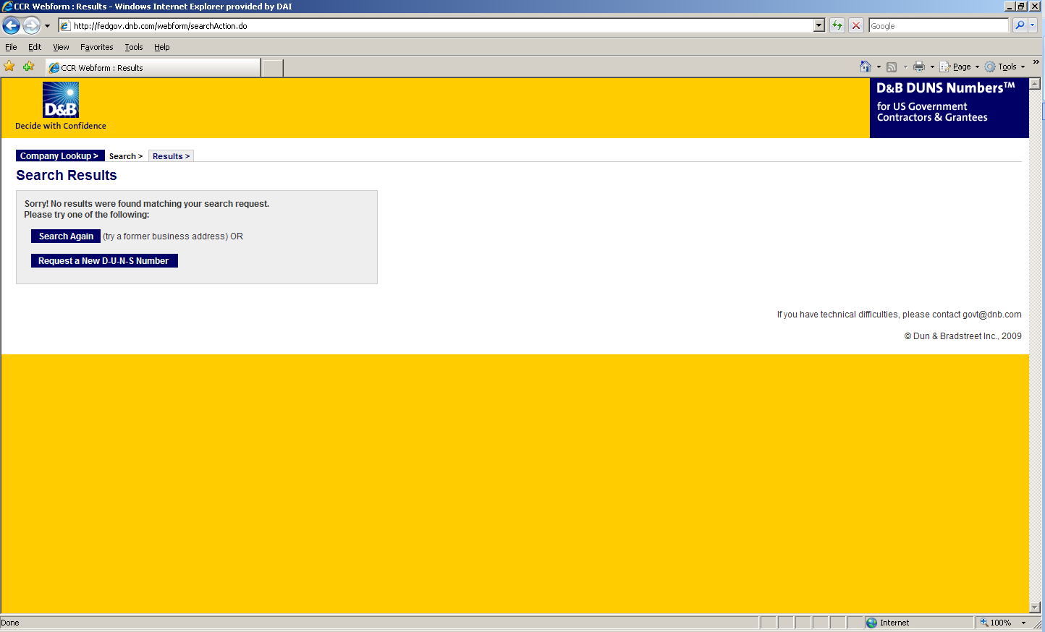

1. Enter the information regarding your organization listed on the next three screens. (See screen shots below.) Make sure you have the following information available (in English) prior to beginning the process of entering this section in order to ensure successful registration.

* Legal Business Name (commas are allowed, periods are not allowed)
* Address
* Phone
* Name of Owner/Executive
* Total Number of Employees
* Annual Sales or Revenue (US Dollar equivalent)
* Description of Operations

1. Note that some fields are Optional, however all other fields must be completed to proceed further with the application process. For example, all applicants must complete the Organization Information sections. The Company Name and Physical Address fields are self-populated based on information previously entered during the initial DUNS search. The question marks to the left of the field provide additional information when you click on them.

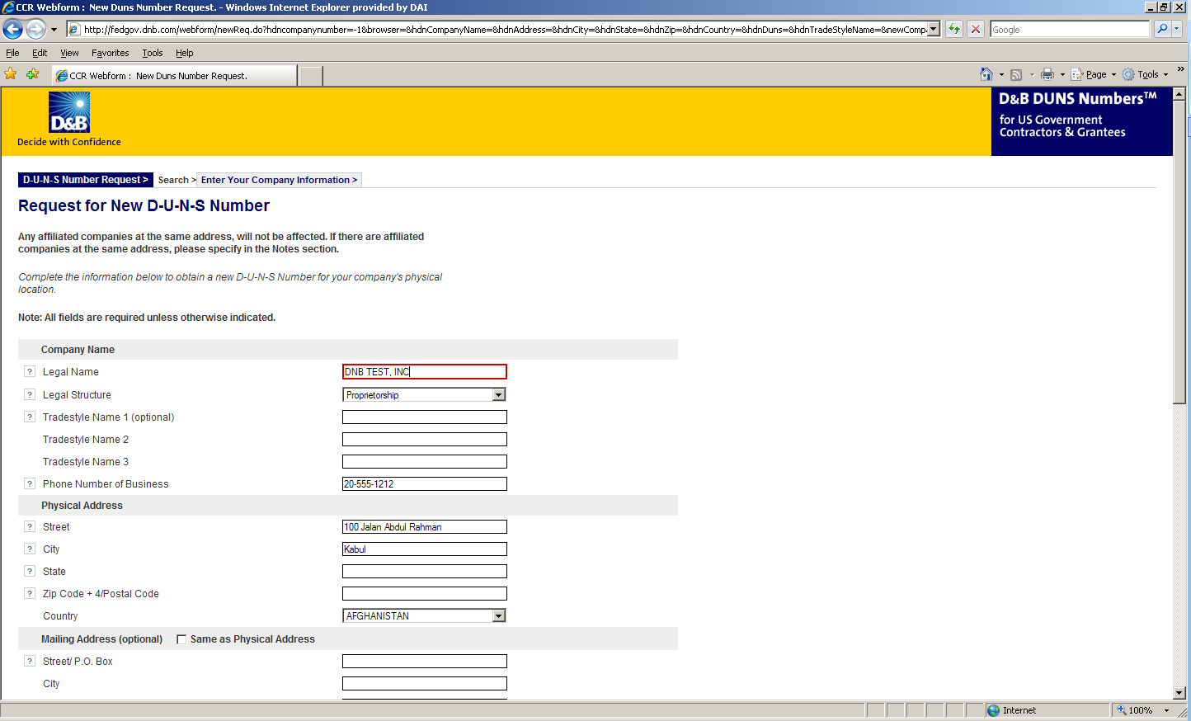

1. You must select the legal structure of your organization from the pull down menu. To assist you in selecting the appropriate structure that best represents your organization, a brief description of the various types follows:

* Corporation – A firm that meets certain legal requirements to be chartered by the state/province in which it is headquartered by the filing of articles of incorporation. A corporation is considered by law to be an entity separate and distinct from its owners. It can be taxed; it can be sued; it can enter into contractual agreements.
* Government - central, province/state, district, municipal and other U.S. or local government entities. Includes universities, schools and vocational centers owned and operated by the government.
* Limited Liability Company (LLC) - This is a type of business ownership combining several features of corporation and partnership structures. It is designed to provide the limited liability features of a corporation and the tax efficiencies and operational flexibility of a partnership. Its owners have limited personal liability for the LLC’s debts and obligations, similar to the status of shareholders in a corporation. If your firm is an LLC, this will be noted on the organizations registration and licensing documents.
* Non-profit - An entity which exists for charitable reasons and is not conducted or maintained for the purpose of making a profit. Any [money](http://www.investorwords.com/3100/money.html) earned must be retained by the organization, and used for its [own](http://www.investorwords.com/3563/own.html) [expenses](http://www.investorwords.com/1842/expense.html), [operations](http://www.investorwords.com/3467/operation.html), and [programs](http://www.investorwords.com/3890/program.html). Most organizations which are registered in the host country as a non-governmental organization (NGO) rather than as a commercial business are anon-profit entities.

Community based organizations, trade associations, community development councils, and similar entities which are not organized as a profit making organization should select this status, even if your organization is not registered formally in country as an NGO.

* Partnership- a legal form of operation in which two or more individuals carry on a continuing business for profit as co-owners. The profits and losses are shared proportionally.
* Proprietorship-These firms are owned by one person, usually the individual who has day-to-day responsibility for running the business. Sole proprietors own all the assets of the business and the profits generated by it.

1. One of the most important fields that must be filled in is the Primary SIC code field. (See screen shot below.) The Primary Standard Industrial Code classifies the business’ most relevant industry and function.

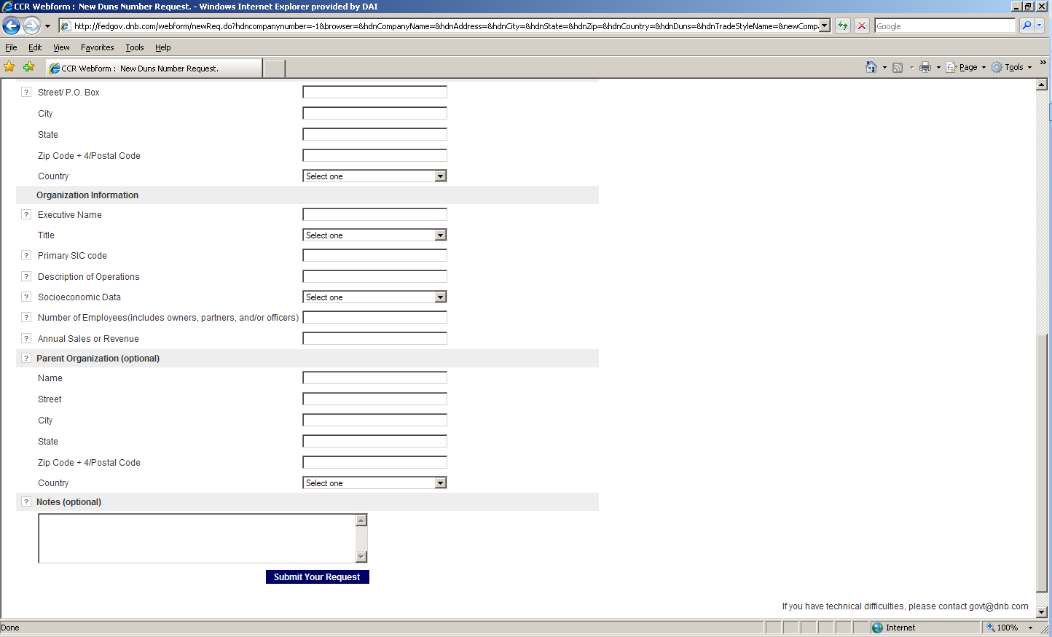

1. If you are unsure of which SIC Code your organization’s core business falls under, please refer to the following website: <http://www.osha.gov/oshstats/sicser.html>

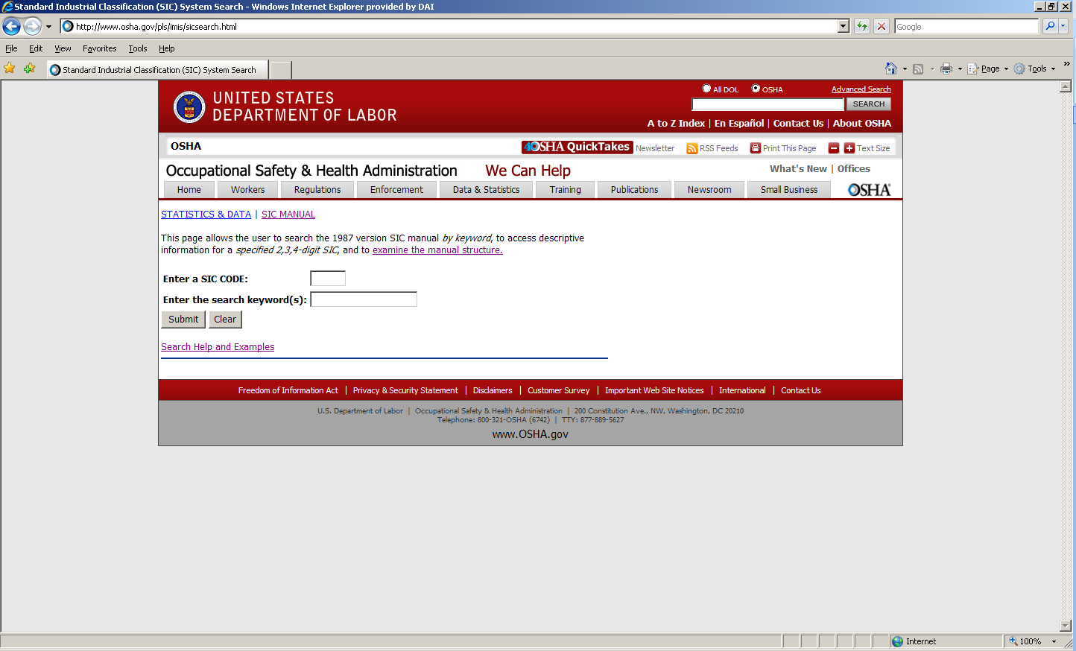

You will need to enter certain keywords to bring up the potential SIC Codes. In the case above, “Research” was entered as the keyword, and resulted in the following:

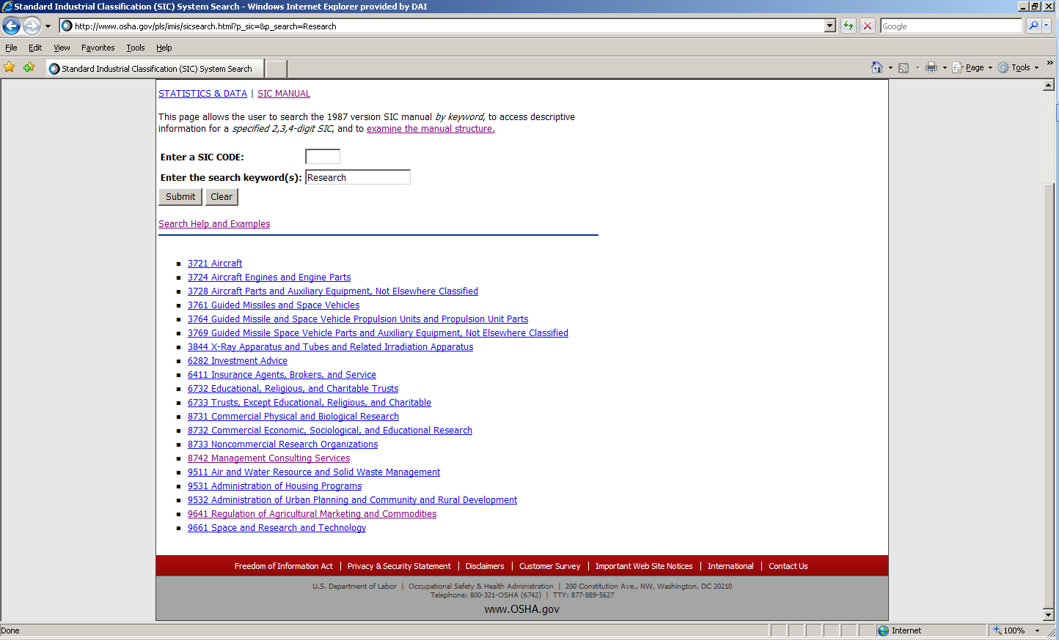

PLEASE NOTE: Many of the DAI subcontractors and grantees fall under one of the following SIC codes:

8742 Management Consulting Services

1542 General Contractors-Nonresidential Buildings, Other than Industrial Buildings and Warehouses or one of the codes within:

|  |
| --- |
| Industry Group 357: Computer And Office Equipment  Industry Group 355: Special Industry Machinery, Except Metalworking  Industry Group 356: General Industrial Machinery And Equipment  Industry Group 359: Miscellaneous Industrial And Commercial |

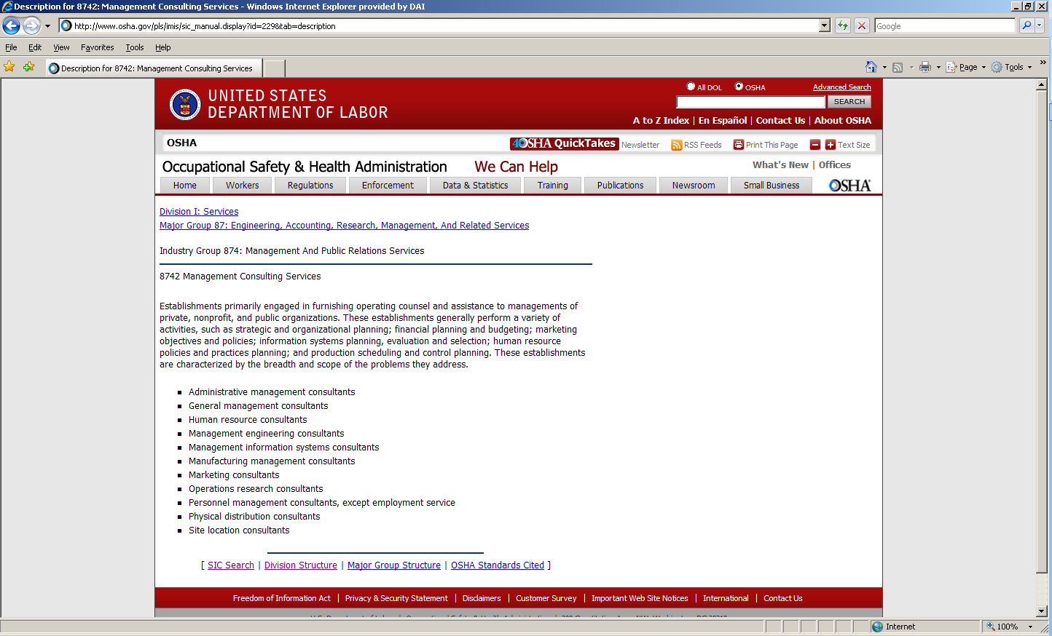

1. Description of Operations- Enter a brief description of the primary services you provide the example below, “agricultural technical assistance” was chosen as the primary function of the business.

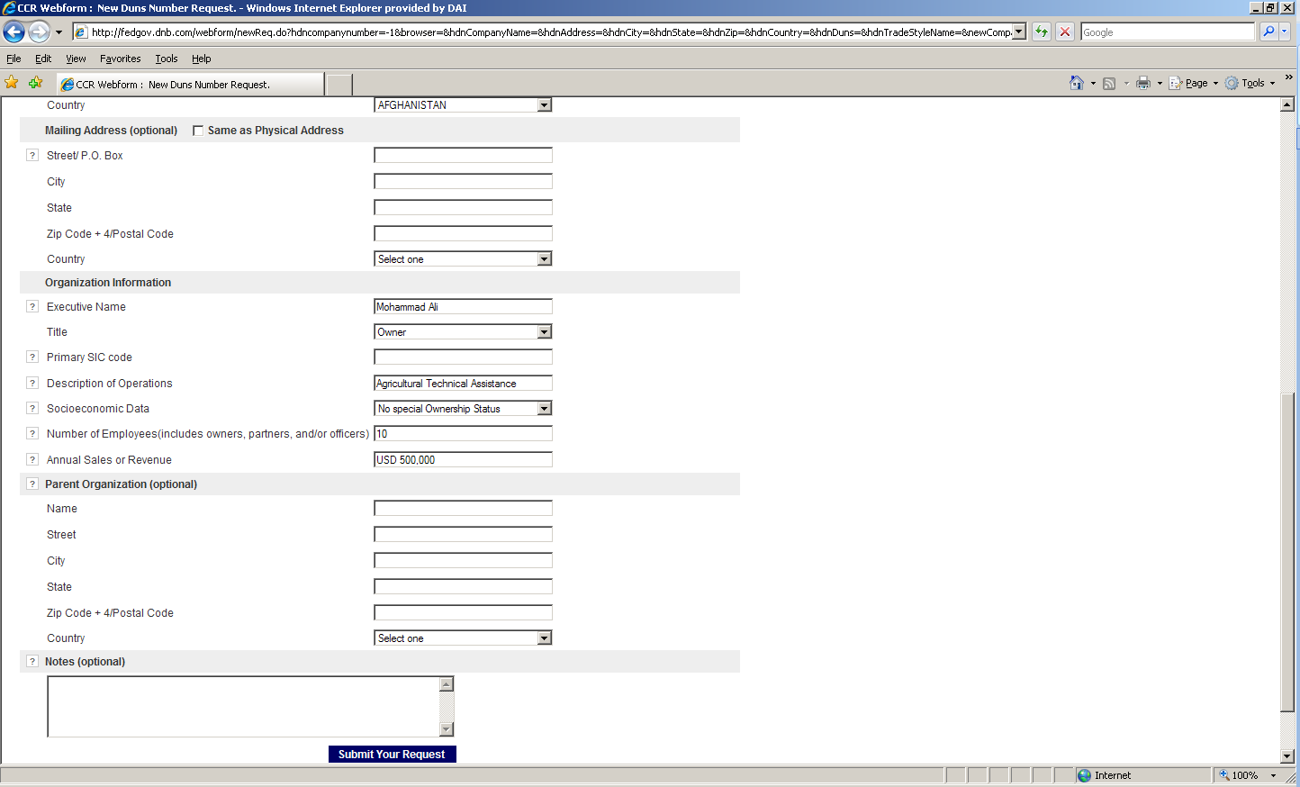

1. The Annual Sales or Revenue figure should be provided in USD (US Dollar) equivalent.
2. Once all of the fields have been completed, click on “Submit Your Request” to be taken to the Verification page.
3. Note: Representative (Principal, Owner or Officer) needs to verify and provide affirmation regarding the accuracy of the data under criminal or civil penalties as per Title 18, Section 1001 of the US Criminal Code.
4. Once “Yes, Continue” button is clicked, the registration application is sent to D&B, and a DUNS number should be available within 24-48 hours. DUNS database can be checked in 24-48 hours by entering the Business Information in the Search window – which should now display a valid result with the new DUNS number for the entity.

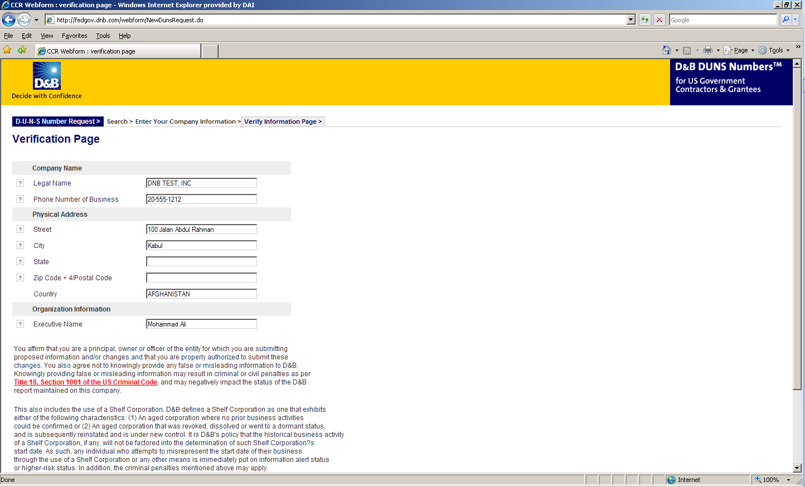

# Attachment E: Self Certification for Exemption from DUNS Requirement

|  |  |
| --- | --- |
| Legal Business Name: |  |
| Physical Address: |  |
| Physical City: |  |
| Physical Foreign Province (if applicable): |  |
| Physical Country: |  |
| Signature of Certifier |  |
| Full Name of Certifier (Last Name, First/Middle Names): |  |
| Title of Certifier: |  |
| Date of Certification (mm/dd/yyyy): |  |

The sub-contractor/vendor whose legal business name is provided herein, certifies that we are an organization exempt from obtaining a DUNS number, as the gross income received from all sources in the previous tax year is under USD $300,000.

*By submitting this certification, the certifier attests to the accuracy of the representations and certifications contained herein. The certifier understands that s/he and/or the sub-contractor/vendor may be subject to penalties, if s/he misrepresents the sub-contractor/vendor in any of the representations or certifications to the Prime Contractor and/or the US Government.

The sub-contractor/vendor agrees to allow the Prime Contractor and/or the US Government to verify the company name, physical address, or other information provided herein. Certification validity is for one year from the date of certification.

# Attachment F: Representations and Certifications of Compliance

1. Federal Excluded Parties List - The Bidder Select is not presently debarred, suspended, or determined ineligible for an award of a contract by any Federal agency.
2. Executive Compensation Certification- FAR 52.204-10 requires DAI, as prime contractor of U.S. federal government contracts, to report compensation levels of the five most highly compensated subcontractor executives to the Federal Funding Accountability and Transparency Act Sub-Award Report System (FSRS)
3. Executive Order on Terrorism Financing- The Contractor is reminded that U.S. Executive Orders and U.S. law prohibits transactions with, and the provision of resources and support to, individuals and organizations associated with terrorism. It is the legal responsibility of the Contractor/Recipient to ensure compliance with these Executive Orders and laws. Recipients may not engage with, or provide resources or support to, individuals and organizations associated with terrorism. No support or resources may be provided to individuals or entities that appear on the Specially Designated Nationals and Blocked persons List maintained by the US Treasury (online at [www.SAM.gov](http://www.SAM.gov)) or the United Nations Security Designation List (online at: http://www.un.org/sc/committees/1267/aq_sanctions_list.shtml). This provision must be included in all subcontracts/sub awards issued under this Contract.
4. Trafficking of Persons – The Contractor may not traffic in persons (as defined in the Protocol to Prevent, Suppress, and Punish Trafficking of persons, especially Women and Children, supplementing the UN Convention against Transnational Organized Crime), procure commercial sex, and use forced labor during the period of this award.
5. Certification and Disclosure Regarding Payment to Influence Certain Federal Transactions – The Bidder certifies that it currently is and will remain in compliance with FAR 52.203-11, Certification and Disclosure Regarding Payment to Influence Certain Federal Transactions.
6. Organizational Conflict of Interest – The Bidder certifies that will comply FAR Part 9.5, Organizational Conflict of Interest. The Bidder certifies that is not aware of any information bearing on the existence of any potential organizational conflict of interest. The Bidder further certifies that if the Bidder becomes aware of information bearing on whether a potential conflict may exist, that Bidder shall immediately provide DAII with a disclosure statement describing this information.
7. Business Size and Classification(s) – The Bidder certifies that is has accurately and completely identified its business size and classification(s) herein in accordance with the definitions and requirements set forth in FAR Part 19, Small Business Programs.
8. Prohibition of Segregated Facilities - The Bidder certifies that it is compliant with FAR 52.222-21, Prohibition of Segregated Facilities.
9. Equal Opportunity – The Bidder certifies that it does not discriminate against any employee or applicant for employment because of age, sex, religion, handicap, race, creed, color or national origin.
10. Labor Laws – The Bidder certifies that it is in compliance with all labor laws..
11. Federal Acquisition Regulation (FAR) – The Bidder certifies that it is familiar with the Federal Acquisition Regulation (FAR) and is in not in violation of any certifications required in the applicable clauses of the FAR, including but not limited to certifications regarding lobbying, kickbacks, equal employment opportunity, affirmation action, and payments to influence Federal transactions.
12. Employee Compliance – The Bidder warrants that it will require all employees, entities and individuals providing services in connection with the performance of an DAI Purchase Order to comply with the provisions of the resulting Purchase Order and with all Federal, State, and local laws and regulations in connection with the work associated therein.

By submitting a proposal, offerors agree to fully comply with the terms and conditions above and all applicable U.S. federal government clauses included herein, and will be asked to sign these Representations and Certifications upon award.

# Attachment G: Full Terms of Contract

The Subcontractor agrees to comply with all applicable requirements, specifications, and conditions of the Prime Contract to the extent to which they are incorporated into this Subcontract Agreement. Any applicable requirements, specifications, and conditions of the Prime Contract, specified by law, are included in this Subcontract Agreement. The clauses in FAR Subpart 52.2 and AIDAR Subpart 752 referenced in the Prime Contract are required to be flowed down to subcontractors, in effect on the date of this Subcontract. In this section, clauses from Section H – Prime Contract Special Requirements – are herein incorporated by reference and are listed below. In addition, other clauses are listed in full text. Whether a clause appears as incorporated by reference or as full text, it applies to this Subcontract Agreement. Unless a current version of a clause is specifically incorporated in the body of this Subcontract, to the extent that an earlier version of any such clause is included in the Prime Contract under which this Subcontract is issued, the date of the clause as it appears in such Prime Contract shall be controlling and said version shall be incorporated herein.

In all such clauses, the term “Contractor” shall mean the Subcontractor performing under this Subcontract, the term “Contract” shall mean this Subcontract, and the terms “Government”, “Contracting Officer” and equivalent phrases shall mean the Contractor and the DAI Contractual Representative, respectively. It is intended that the referenced clauses shall apply to the Subcontractor in such manner as is necessary to reflect the position of the Subcontractor as a subcontractor to the Prime Contractor, to insure the Subcontractor’s obligations to the Prime Contractor and to the U.S. Government, and to enable the Prime Contractor to meet its obligations under its Prime Contract. Clauses not requiring flow down from the Contractor to the Subcontractor, but nevertheless specified herein shall have full force and effect in performance of this Subcontract.

**Clauses Incorporated by Reference**

This Subcontract incorporates one or more of the following clauses by reference, suitably modified to properly identify the parties, with same force and effect as if they were given in full text. The complete text will be made available to Subcontractor upon request. The full text may also be accessed electronically at the following website: http://www.arnet.gov/far/

The following contract clauses pertinent to this section are hereby incorporated by reference (by Citation Number, Title, and Date) in accordance with the clause at FAR "52.252-2 Clauses Incorporated By Reference" in Section H of this contract. See FAR 52.252-2 for an internet address (if specified) for electronic access to the full text of a clause.

**G.1. LANGUAGE REQUIREMENTS**

All reports and deliverables shall be produced in English. Products specifically developed for the Government of Ukraine and Ukrainian organizations, including information products whose intended audience is Ukrainians, shall also be produced in Ukrainian.

**G.2. LOGISTIC SUPPORT**

The Contractor shall be responsible for furnishing all logistic support in the United States and overseas unless otherwise stated in the contract.

The Contractor shall address all requirements under U.S. and local law for the transfer of property and shall provide the inventory schedule required by FAR 52.245-1. The proposed property disposition shall be approved in writing by the Contracting Officer.

**G.3. AUTHORIZED GEOGRAPHIC CODE**

The authorized Geographic Codes for procurement of goods and services under this contract is 110.

**G.4. PROHIBITION ON THE USE OF FEDERAL FUNDS TO PROMOTE, SUPPORT, OR ADVOCATE THE LEGALIZATION OR PRACTICE OF PROSTITUTION– TIP ACQUISITION**

(a) The U.S. Government is opposed to prostitution and related activities, which are inherently harmful and dehumanizing, and contribute to the phenomenon of trafficking in persons. None of the funds made available under this contract may be used to promote, support, or advocate the legalization or practice of prostitution. Nothing in the immediately preceding sentence shall be construed to preclude assistance designed to ameliorate the suffering of, or health risks to, victims while they are being trafficked or after they are out of the situation that resulted from such victims being trafficked.

(b) The Contractor shall insert this clause, in its entirety, in all sub-awards under this award.

(c) This provision includes express terms and conditions of the contract and any violation of it shall be grounds for unilateral termination of the contract, in whole or in part, by USAID prior to the end of the term.

**G.5. USAID IMPLEMENTATION OF SECTION 508 OF THE REHABILITATION ACT OF 1973 AND FEDERAL ACQUISITION CIRCULAR (FAC) 97-27 "ELECTRONIC AND INFORMATION TECHNOLOGY ACCESSIBILITY**

In accordance with ADS 302, Contractor shall comply with USAID Implementation of Section 508 of the Rehabilitation Act of 1973 and Federal Acquisition Circular (FAC) 97-27 "Electronic and Information Technology Accessibility**.** Further information on Section 508 is available via the Internet at: <http://www.section508.gov> and https://www.usaid.gov/sites/default/files/documents/1868/302.pdf.

**G.6. CONTRACTOR’S PERSONNEL INTEGRITY IN FOREIGN ASSISTANCE**

In accordance with FAR 52.203-13, the Contractor shall exercise due diligence on personnel to be engaged under this contract to ensure that proposed candidates were not directly involved in or associated with any dubious activities, including the recent U.S. financial scandals, and that their employment histories and past conduct display integrity congruent with the program goals.

**G.8. GOVERNMENT FURNISHED FACILITIES OR PROPERTY**

(a) The Contractor and any employee or consultant of the Contractor is prohibited from using U.S. Government facilities (such as office space or equipment) or U.S. Government clerical or technical personnel in the performance of the services specified in the Task Order unless the use of Government facilities or personnel is specifically authorized in the Task Order or is authorized in advance, in writing, by the CO.

(b) If at any time, it is determined that the Contractor, or any of its employees or consultants, have used U.S. Government facilities or personnel either in performance of the contract itself, or in advance, without authorization in, in writing, by the Contracting Officer, then the amount payable under the contract shall be reduced by an amount equal to the value of the U.S. Government facilities or personnel used by the Contractor, as determined by the Contracting Officer.

(c) If the parties fail to agree on an adjustment made pursuant to this clause it shall be considered a "dispute" and shall be dealt with under the terms of the "Disputes" clauses of the contract.

**G.9. AIDAR 752.229-71 REPORTING OF FOREIGN TAXES (JUL 2007)**

(a) The contractor must annually submit a report by April 16 of the next year.

(b) Contents of report. The report must contain:

(1) Contractor name.

(2) Contact name with phone, fax number and email address.

(3) Contract number(s).

(4) Amount of foreign taxes assessed by a foreign government [each foreign government must be listed separately] on commodity purchase transactions valued at $500 or more financed with U.S. foreign assistance funds under this agreement during the prior U.S. fiscal year.

(5) Only foreign taxes assessed by the foreign government in the country receiving U.S. assistance are to be reported. Foreign taxes by a third party foreign government are not to be reported. For example, if a contractor performing in Lesotho using foreign assistance funds should purchase commodities in South Africa, any taxes imposed by South Africa would not be included in the report for Lesotho (or South Africa).

(6) Any reimbursements received by the contractor during the period in paragraph (b)(4) of this clause, regardless of when the foreign tax was assessed and any reimbursements on the taxes reported in paragraph (b)(4) of this clause received through March 31.

(7) Report is required even if the contractor did not pay any taxes during the reporting period.

(8) Cumulative reports may be provided if the contractor is implementing more than one program in a foreign country.

(c) Definitions. As used in this clause—

(1) Agreement includes USAID direct and country contracts, grants, cooperative agreements and interagency agreements.

(2) Commodity means any material, article, supply, goods, or equipment.

(3) Foreign government includes any foreign governmental entity.

(4) Foreign taxes mean value-added taxes and customs duties assessed by a foreign government on a commodity. It does not include foreign sales taxes. (d) Where. Submit the reports to: DAI Kyiv Office

(e) Subagreements. The contractor must include this reporting requirement in all applicable subcontracts and other subagreements.

(f) For further information see http://2001-2009.state.gov/s/d/rm/c10443.htm.

**G.11. AIDAR 752.7101 VOLUNTARY POPULATION PLANNING ACTIVITIES (JUN 2008)**

(a) *Requirements for Voluntary Sterilization Program.* None of the funds made available under this contract shall be used to pay for the performance of involuntary sterilization as a method of family planning or to coerce or provide any financial incentive to any individual to practice sterilization.

(b) *Prohibition on Abortion-Related Activities.*

(1) No funds made available under this contract will be used to finance, support, or be attributed to the following activities: (i) procurement or distribution of equipment intended to be used for the purpose of inducing abortions as a method of family planning; (ii) special fees or incentives to any person to coerce or motivate them to have abortions; (iii) payments to persons to perform abortions or to solicit persons to undergo abortions; (iv) information, education, training, or communication programs that seek to promote abortion as a method of family planning; and (v) lobbying for or against abortion. The term “motivate”, as it relates to family planning assistance, shall not be construed to prohibit the provision, consistent with local law, of information or counseling about all pregnancy options.

(2) No funds made available under this contract will be used to pay for any biomedical research which relates, in whole or in part, to methods of, or the performance of, abortions or involuntary sterilizations as a means of family planning. Epidemiologic or descriptive research to assess the incidence, extent or consequences of abortions is not precluded.

(c) The Contractor shall insert this provision in all subcontracts.

**G.14. AIDAR 752.222-71 NONDISCRIMINATION (JUNE 2012)**

FAR Part 27 and the clauses prescribed in that part prohibit contractors performing in or recruiting from the U.S. from engaging in certain discriminatory practices.

USAID is committed to achieving and maintaining a diverse and representative workforce and a workplace free of discrimination. Based on law, Executive Order, and Agency policy, USAID prohibits discrimination in its own workplace on the basis of race, color, religion, sex (including pregnancy and gender identity), national origin, disability, age, veteran’s status, sexual orientation, genetic information, marital status, parental status, political affiliation, and any other conduct that does not adversely affect the performance of the employee. USAID does not tolerate any type of harassment, either sexual or nonsexual, of any employee or applicant for employment. Contractors are required to comply with the nondiscrimination requirements of the FAR.

In addition, the Agency strongly encourages all its contractors (at all tiers) to develop and enforce comprehensive nondiscrimination policies for their workplaces that include protection on these expanded bases, subject to applicable law.

**G.15. AIDAR 752.7036 USAID IMPLEMENTING PARTNER NOTICES (IPN) PORTAL FOR ACQUISITION (JULY 2014)**

a) Definitions

“USAID Implementing Partner Notices (IPN) Portal for Acquisition (“IPN Portal”)” means the single point where USAID posts universal bilateral modifications, which can be accessed electronically by registered USAID contractors. The IPN Portal is located at https://sites.google.com/site/ipnforacquisitions/.

“IPN Portal Administrator” means the USAID official designated by the M/OAA Director, who has overall responsibility for managing the USAID Implementing Partner Notices Portal for Acquisition.

“Universal bilateral modification” means modifications such as those that update or incorporate new FAR or AIDAR clauses, other terms and conditions, or special requirements that affect all awards or a class of awards as specified in the Agency notification of such terms and conditions or special requirements.

b) By submission of an offer and execution of a contract, the Offeror/Contractor acknowledges the requirement to:

(1) Register with the IPN Portal if awarded a contract resulting from this solicitation, and

(2) Receive universal bilateral modifications to this contract and general notices via the IPN Portal.

c) Procedure to register for notifications.

Go to: https://sites.google.com/site/usaidipnforacquisitions/ and click the “Register” button at the top of the page. Contractor representatives must use their official organization email address when subscribing, not personal email addresses.

d) Processing of IPN Portal Modifications

The contractor may access the IPN Portal at any time to review all IPN Portal modifications; however, the system will also notify the contractor by email when the USAID IPN Portal Administrator posts a universal bilateral modification for contractor review and signature. Proposed IPN Portal modifications distributed via the IPN Portal are applicable to all awards, unless otherwise noted in the proposed modification.

Within 15 calendar days from receipt of the notification email from the IPN Portal, the contractor must do one of the following:

(1) (a) verify applicability of the proposed modification for their award(s) per the instructions provided with each modification; (b) download the modification and incorporate the following information on the SF30 form: contract number, organization name, and organization mailing address as it appears in the basic award; (c) sign the hardcopy version; and (d) send the signed modification (by email or hardcopy) to the CO for signature. The contractor must not incorporate any other changes to the IPN Portal modification. Bilateral modifications provided through the IPN Portal are not effective until the both the contractor and the CO sign the modification;

(2) Notify the Contracting Officer in writing if the modification requires negotiation of additional changes to terms and conditions of the contract; or

(3) Notify the Contracting Officer that the contractor declines to sign the modification.

Within 30 calendar days of receipt of a signed modification from the contractor, the CO must provide the fully executed modification to the contractor or initiate discussions with the contractor.

**G.18 752.204-71 PARTNER VETTING (FEB 2012)**

(a) The Contractor must comply with the vetting requirements for key individuals under this contract.

(b) Definitions. As used in this provision—

*Key individual* means:

(i) Principal officers of the organization's governing body (e.g., chairman, vice chairman, treasurer and secretary of the board of directors or board of trustees);

(ii) The principal officer and deputy principal officer of the organization (*e.g.,* executive director, deputy director, president, vice president);

(iii) The program manager or chief of party for the USG-financed program; and

(iv) Any other person with significant responsibilities for administration of the

USG-financed activities or resources, such as key personnel as described in Automated Directives System Chapter 302. Key personnel, whether or not they are employees of the prime contractor, must be vetted.

*Vetting official* means the USAID employee identified in paragraph (d) of this clause as having responsibility for receiving vetting information, responding to questions about information to be included on the USAID Partner Information Form, USAID Form 500-13, coordinating with the USAID Office of Security, and conveying the vetting determination to each Contractor, potential subcontractors subject to vetting, and to the contracting officer. The vetting official is not part of the contracting office and has no involvement in the source selection process.

(c) The Contractor must submit a USAID Partner Information Form, USAID Form 500-13, to the vetting official identified below during the contract when the Contractor replaces key individuals with individuals who have not been previously vetted for this contract. Note: USAID will not approve any key personnel who have not passed vetting.

(d) The designated vetting official is:

DAI Contracts Manager

(e)(1) The vetting official will notify the Contractor that it—

(i) Has passed vetting,

(ii) Has not passed vetting, or

(iii) Must provide additional information, and resubmit the USAID Partner Information Form with the additional information within the number of days the vetting official specifies.

(2) The vetting official will include in the notification any information that USAID's Office of Security (SEC) determines releasable. In its determination, SEC will take into consideration the classification or sensitivity of the information, the need to protect sources and methods, or status of ongoing law enforcement and intelligence community investigations or operations.

(f) *Reconsideration.* (1) Within 7 calendar days after the date of the vetting official's notification, the contractor or prospective subcontractor that has not passed vetting may request in writing to the vetting official that the Agency reconsider the vetting determination. The request should include any written explanation, legal documentation and any other relevant written material for reconsideration.

(2) Within 7 calendar days after the vetting official receives the request for reconsideration, the Agency will determine whether the contractor's additional information warrants a revised decision.

(3) The Agency's determination of whether reconsideration is warranted is final.

04/22/2016 Partial Revision

(g) A notification that the Contractor has passed vetting does not constitute any other approval under this contract.

(h) When the Contractor anticipates awarding a subcontract for which consent is required under (48 CFR) FAR clause 52.244-2, Subcontracts, the subcontract is subject to vetting. The prospective subcontractor must submit a USAID Partner Information Form, USAID Form 500-13, to the vetting official identified in paragraph (d) of this clause. The contracting officer must not consent to award of a subcontract to any organization that has not passed vetting when required.

(i) The Contractor agrees to incorporate the substance of paragraphs (a) through (g) of this clause in all subcontracts under this contract.

Alternate I (FEB 2012). As prescribed in 704.7005(b)(2), substitute paragraphs (h) and (i) below for paragraphs (h) and (i) of the basic clause:

(h)(1) When the Contractor anticipates awarding a subcontract for which consent is required under (48 CFR) FAR clause 52.244-2, Subcontracts, the subcontract is subject to vetting. The prospective subcontractor must submit a USAID Partner Information Form, USAID Form 500-13, to the vetting official identified in paragraph (d) of this clause. The contracting officer must not consent to award of a subcontract to any organization that has not passed vetting when required.

(2) In addition, prospective subcontractors at any tier providing the following classes of items (supplies and services): must pass vetting. Contractors must not place subcontracts for these classes of items until they receive confirmation from the vetting official that the prospective subcontractor has passed vetting.

(i) The Contractor agrees to incorporate the substance of this clause in all subcontracts under this contract.